Zoho Webinar in Zoho CRM — Build Specification
This document was written by clicking through the mock at webinar.html as it stands on master, screen by screen, and by reading the rule sets out of the page's own JavaScript. Every screenshot in it is a real capture from that file, not a redraw. Every picklist value is listed in the order the UI shows it. Where the mock does not answer a question, the document says so in an Open question callout rather than filling the gap with a guess — so a sentence here is either something you can see in the mock, or something explicitly marked as undecided.
It is written to be built from. If you have to open the mock to answer a question about a field, a state or a rule, this document has failed; tell us which question, and it gets fixed.
The business used in the examples is Northline Capital, a wealth-management firm. They advise business owners on their money and earn on the portfolios they end up managing. They cannot cold-call their way to a portfolio, so once a month they run a free market-outlook webinar — an hour on where rates are going, no pitch until the last five minutes. Two hundred people register, sixty turn up, and that room is the top of the pipeline. Jay is an advisor there, and his screen is the one every flow in this document is seen from.

Contents
- Introduction
- Turning the integration on
- Creating a webinar
- Co-organisers
- The registration page
- The webinar list
- A webinar that hasn't happened yet
- A webinar that has happened
- On-demand webinars
- The emails
- Attribution
- Things we still need to decide
- Appendix A — every field in the create form
- Appendix B — integration settings, templates and directories

1. Introduction

What Zoho Webinar is
Zoho Webinar is Zoho's webinar product. You schedule a session, publish a registration form, and people sign up. The product emails them along the way — an invitation, a confirmation when they register, up to three reminders before it starts, and afterwards a follow-up that differs depending on whether they turned up. It runs the session itself, and it keeps what happened in the room: the polls you ran, the questions people asked, the recording, the files you shared.
None of that is missing today. Zoho Webinar does the webinar well.

What it cannot do on its own
It has no business context. Sixty people attended Jay's outlook webinar; Zoho Webinar can tell him sixty names, sixty email addresses and what each of them did in the hour. It cannot tell him the only thing he needs on Monday morning: who to call first.
Three questions, none of which the webinar can answer on its own:
- Who is worth the call? Sixty names, ranked how?
- Is this question a signal? Someone asked "what is your minimum portfolio size" — chase it or not?
- What do we already know about them? Have we spoken? Is there a proposal out?
The middle one is the sharpest. That question from a stranger who found the webinar on LinkedIn is a curious browser. The identical question from someone Jay has met twice, with a proposal sitting at negotiation, is a buying signal. Same words, completely different follow-up — and the webinar shows both of them the same way, because it had never heard of either person before they registered.
Northline already holds that context. Every client and every lead is in CRM, with the history, the calls and the open deals. It just has no idea the webinar happened. So today the only thing joining the two halves is somebody exporting a spreadsheet:
- Export a recipient list out of CRM to invite anyone, so the invite goes to whatever the data looked like on export day rather than to the record as it stands.
- Re-import the registrants afterwards, hand-matching the ones who already exist so as not to create duplicates.
- Guess at the result, because attendance lives in one product and pipeline in the other.

What this integration closes
Zoho Webinar becomes a module inside CRM, sitting in the left nav alongside Leads and Contacts, and each webinar is a record like any other:
- Invite CRM records directly, so the invite always goes to current data — and to whichever modules the admin allows, not only Leads and Contacts.
- Registrations, joins and no-shows land back on the webinar record, with the option of creating CRM records from registrants who were not in CRM to begin with, so there is nothing to re-import.
- The whole email lifecycle is sent from CRM — invitation, confirmation, up to three reminders, and separate follow-ups for attendees and absentees — from templates that live with the module.
- Attendance is tied to the deals it influenced, through an attribution model chosen once in setup, so what a webinar was worth is a figure on the record instead of a feeling.
Note
One sentence to hold on to for the rest of the document: before the webinar the record collects, after the webinar it reports. Nearly every difference between the two record states follows from that.

2. Turning the integration on

Where it starts
Setup ▸ Marketplace ▸ Zoho lists the Zoho apps that connect to CRM. Zoho Webinar and Zoho Meetings share one card, because they share one login: For webinars and For online meetings are set up independently, and the note on the card says so.
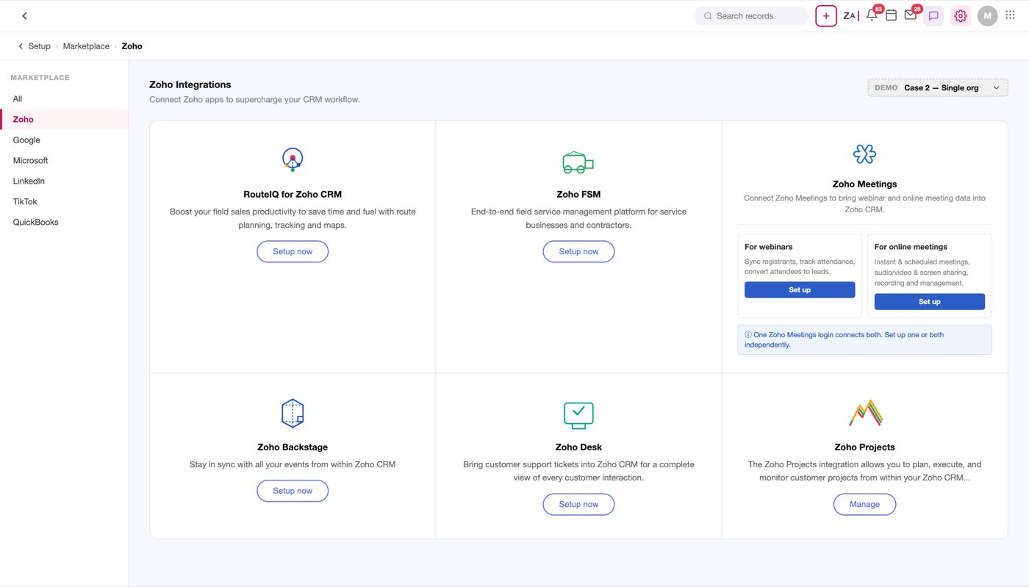
Figure 1 — Setup ▸ Marketplace ▸ Zoho. One card carries both paths. The DEMO switcher at the top right is a mock-only control for walking the blocking states below
Note
The DEMO dropdown exists only in the mock. It selects which account situation to simulate, and is how the five cases below are reached. window._selectedCase defaults to 2.

The account question is answered at the card
Clicking Set up checks the account situation before showing anything else — integWebinarCardSetup() branches on the case and returns early for the three that cannot proceed. This matters: a user with no Zoho Webinar account is not walked through a marketing page and a four-step form before being told they cannot have it.
Case | Situation | What happens
1 | No Zoho Webinar account for this email | Modal offering to create one
2 | One Webinar organisation | Straight to the introduction page
3 | Several organisations | Introduction page, then an org picker in step 1
4 | Account exists, user is a Member not an Admin | Modal explaining only Admins can connect
5 | Trial expired | Modal explaining the trial has ended

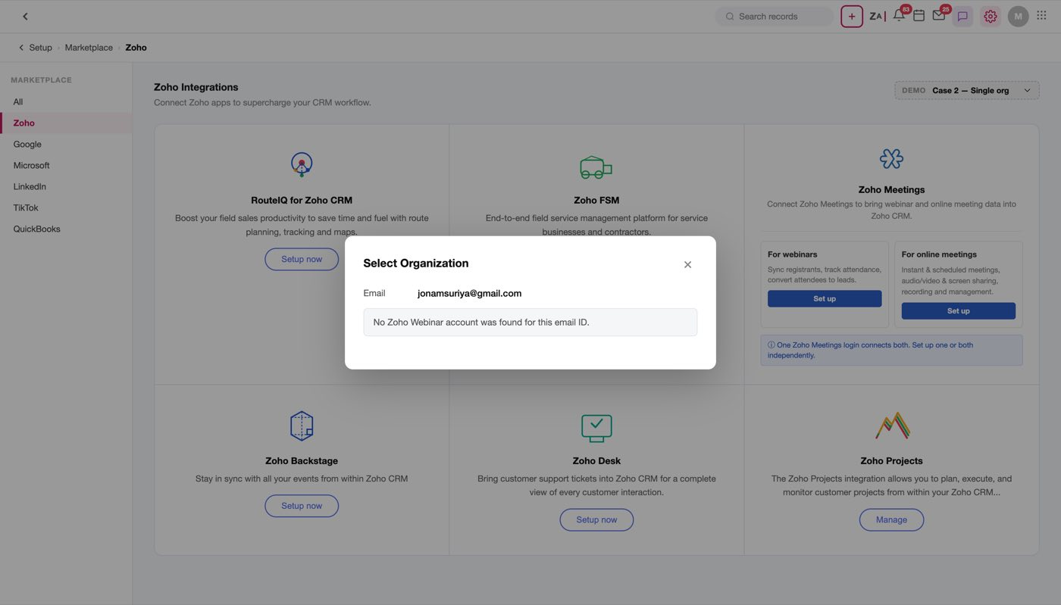
Figure 2 — Case 1. The only way forward is creating a Webinar account
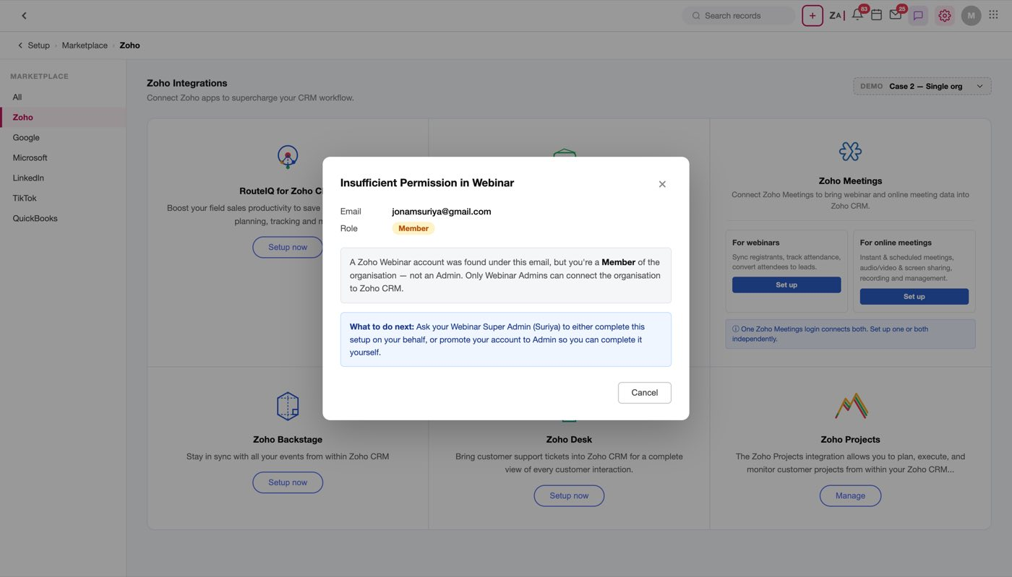
Figure 3 — Case 4. A Member cannot connect the integration. The modal has no action beyond Cancel — the "Notify Super Admin" button was deliberately removed, because CRM cannot actually send that mail
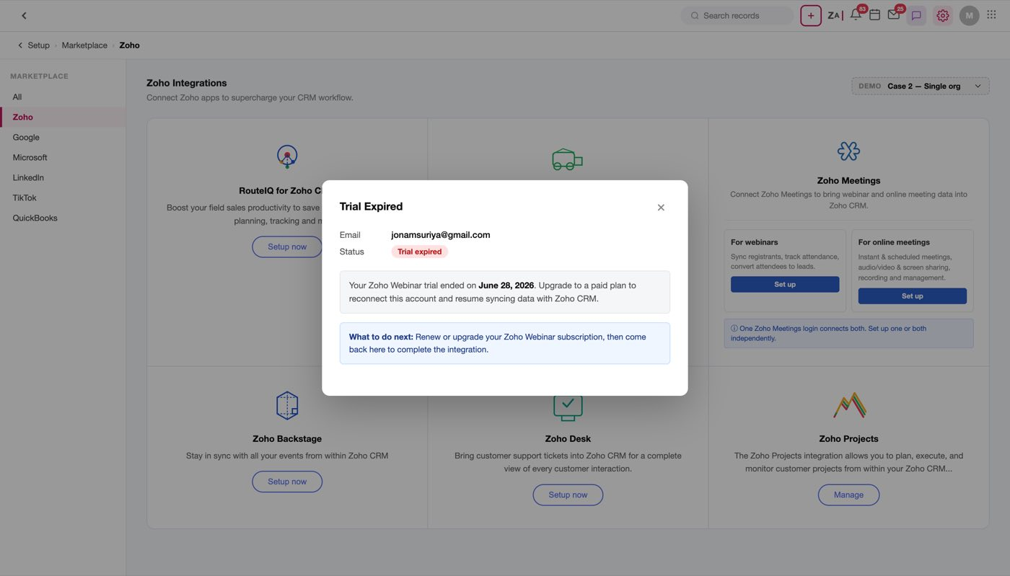
Figure 4 — Case 5. Trial expired

The introduction page comes before the form
Cases 2 and 3 land on an introduction page rather than on settings. It explains what the integration makes possible — what you get, and what it solves — and the only action on it is Setup at the top right. The badge next to the title reads NOT ENABLED until the integration is on, and flips to a green ENABLED afterwards, at which point the same button opens the enabled settings panel instead of the form.
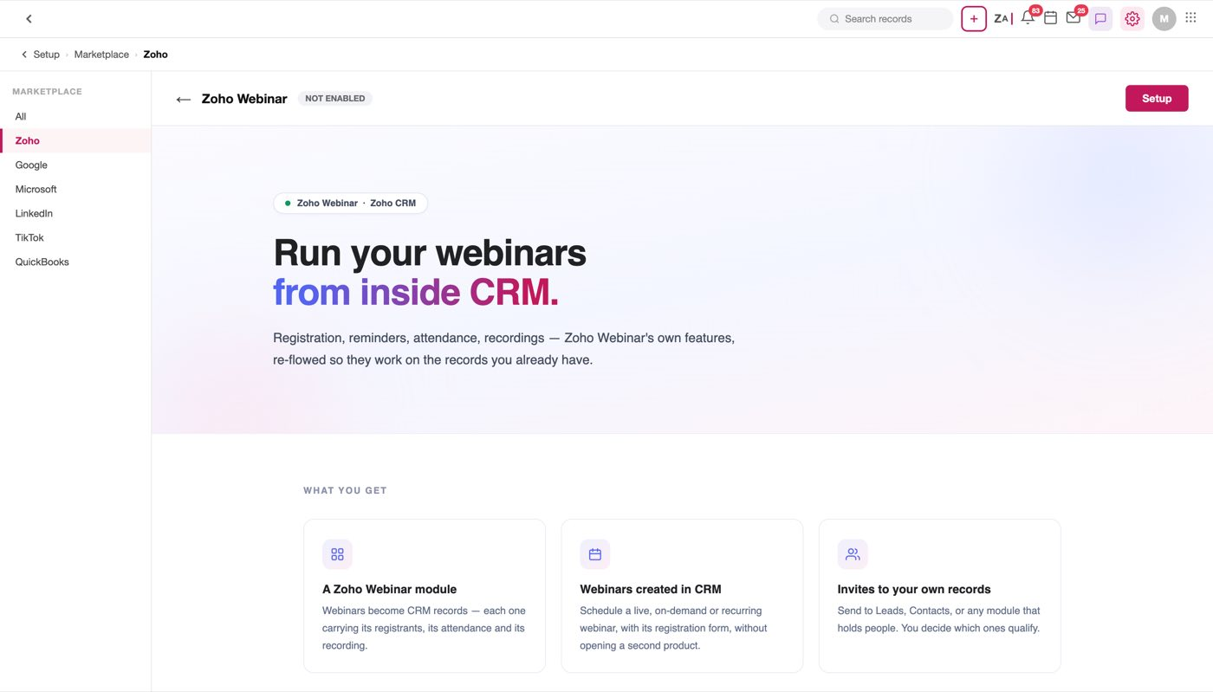
Figure 5 — The introduction page. Setup is the only action; the body has no buttons at all
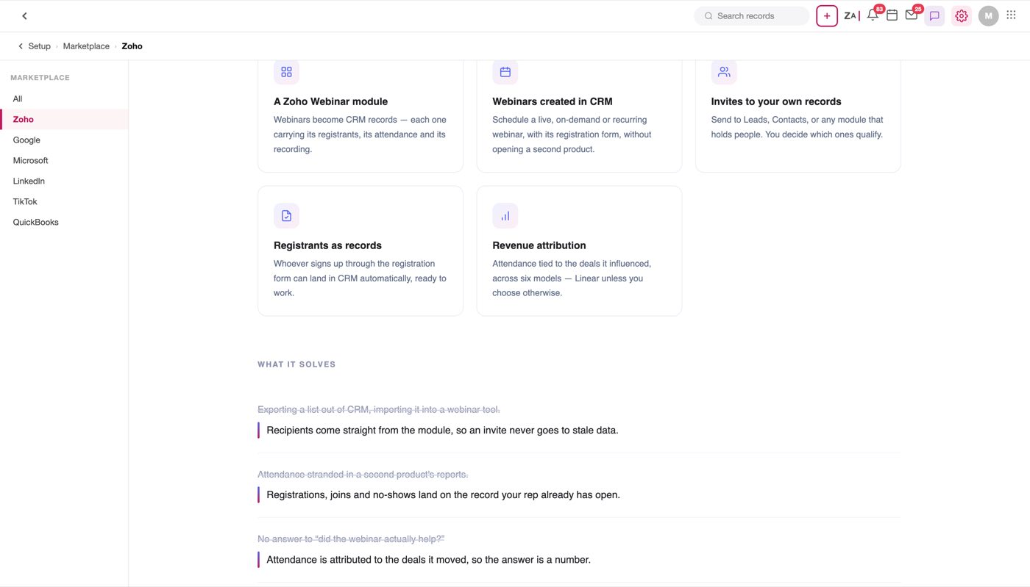
Figure 6 — What you get — five features, each with what it changes for the user
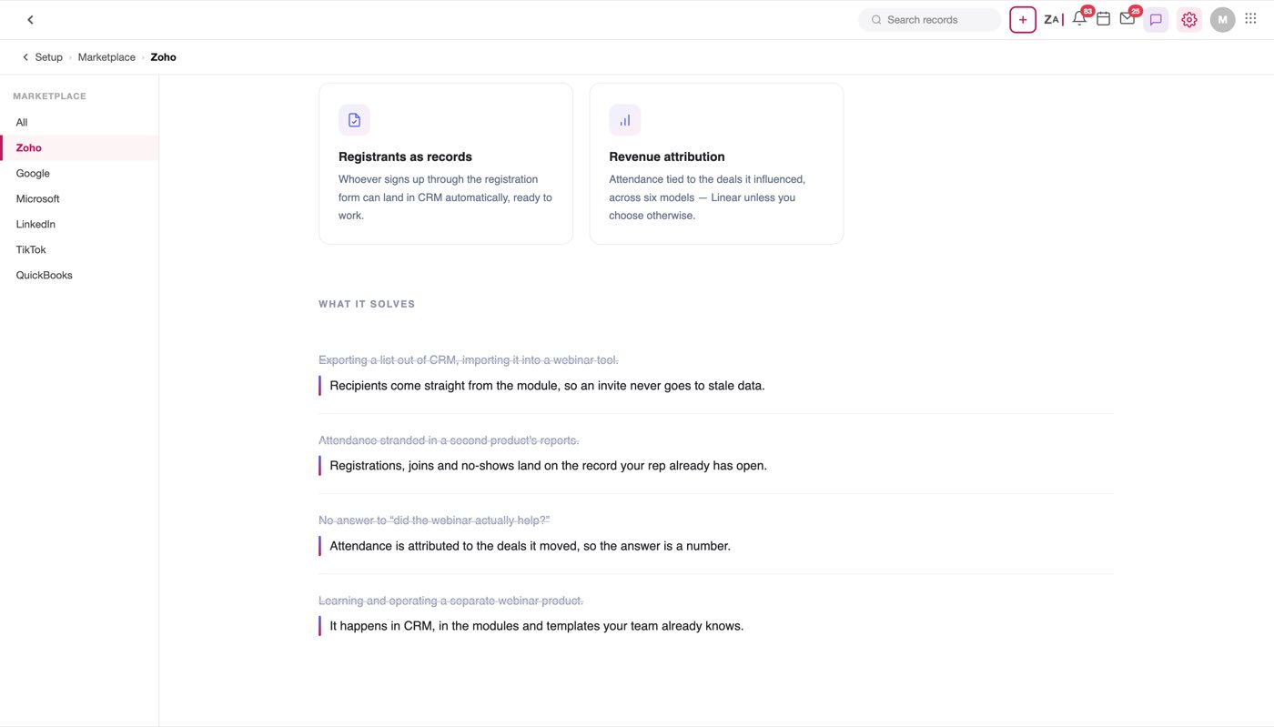
Figure 7 — What it solves. Each old way strikes itself through as the row arrives, answered by the line beneath it

Setup is a four-step wizard, and the steps accumulate
Setup opens a wizard: four steps, each with Cancel and Next, and the last Next reading Enable Integration. Answering a step does not hide it — every answered step stays on the page, so while choosing an attribution model you can still scroll up and re-read which modules you allowed. Only the step you are on carries the two buttons; earlier footers are hidden, because a pair of buttons under a settled section reads as though it is still in play.
Cancel abandons setup and returns to the introduction page, or to the enabled panel if the integration is already on. Re-opening the setup panel always resets to step 1 — integShowPanel('integ-setup-panel') calls setupStep(1) — so a second visit never resumes mid-wizard.
Note
The steps are .wz-step blocks shown and hidden in place, not four separate pages. That is deliberate: setupActivateIntegration() reads the answers straight out of the DOM at the end, so every earlier field has to still exist when the last button is pressed.

Step 1 — Email and organisation. The Zoho account being connected, and which Webinar organisation to connect it to. The organisation picklist lists the orgs on that account (in the mock: Acme Corp Webinars, ClientCo Marketing, Consulting Practice) and carries the rule underneath it: "Only one organisation can be connected to CRM at a time." Case 3 is the reason this field exists.
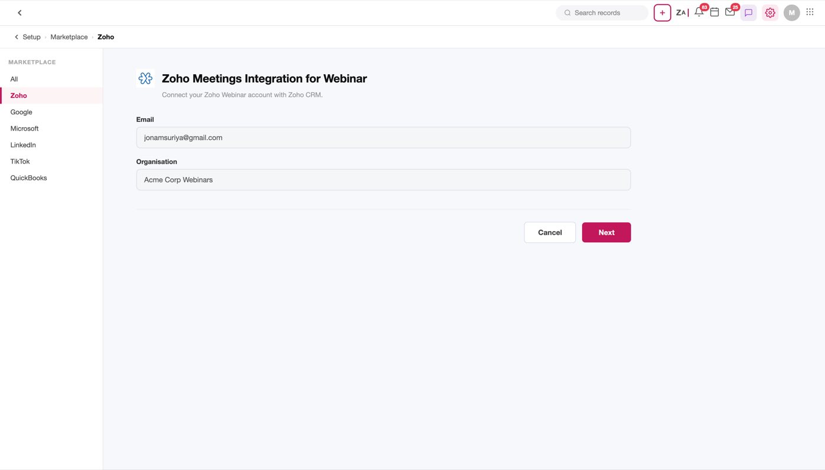
Figure 8 — Step 1. Email, organisation, and the one-org-at-a-time rule
Step 2 — Sync past webinars? A Yes/No radio pair, Yes preselected. Yes imports the webinars that already exist in the connected Webinar organisation, so the module is not empty on day one.
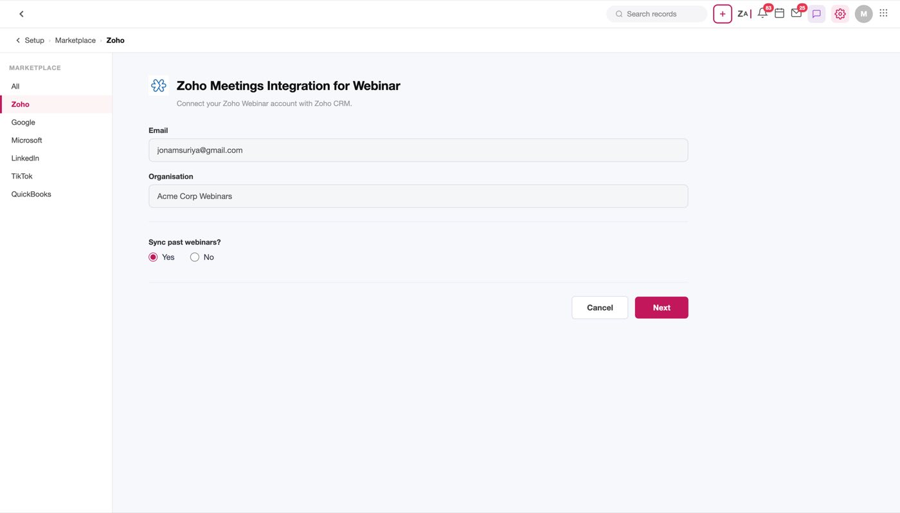
Figure 9 — Step 2, with step 1 still above it — scroll up and the connection is still there to re-read
Step 3 — Who Can Participate From CRM. Which CRM modules a webinar invite may be sent to. One card, a search box, a flat checkbox list. Leads and Contacts are mandatory — checked, red asterisk, muted label, and imToggle() returns early for anything in IM_LOCKED, so they cannot be turned off. Everything else starts unchecked.
This is the section with the longest reach: it drives the module dropdown in Send Invite. Turn a module off here and its records can no longer be added to a webinar.
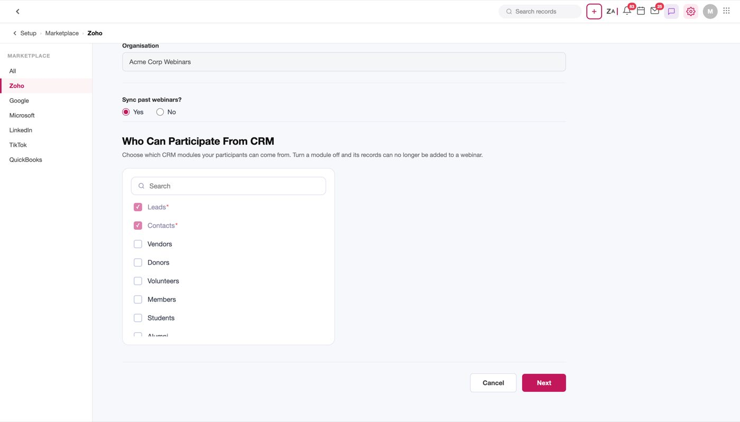
Figure 10 — Step 3. Leads and Contacts are locked on; the rest of the list is the modules a business builds to hold people
Step 4 — Webinar Deal Attribution. Whether to attribute deal revenue to webinars at all, and if so, under which model. The section explains itself first — "Webinar Deal Attribution tells you which webinars actually helped close your deals" — then offers Enable Deal Revenue Attribution, and below it the six models as cards, each with a worked example. Linear is selected by default, and the copy is explicit that the whole thing is optional: "Deal Attribution is optional. You can enable it later from the integration settings if you'd prefer to skip this for now."
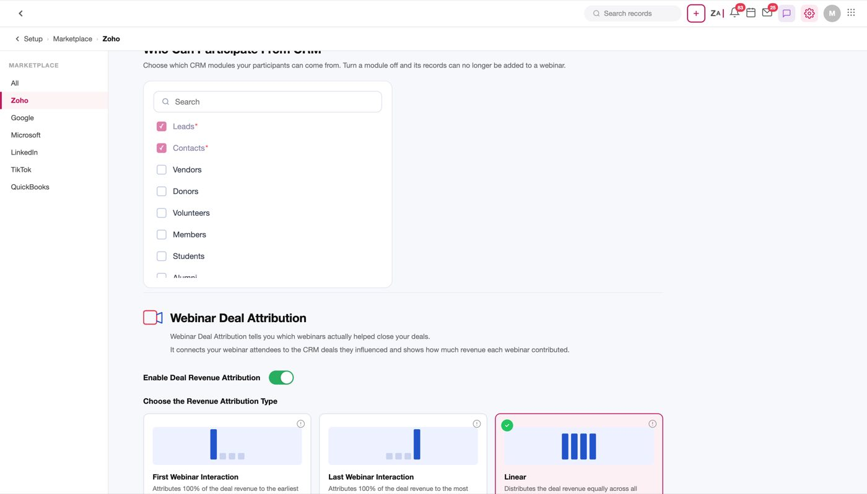
Figure 11 — Step 4. The explanation comes before the choice
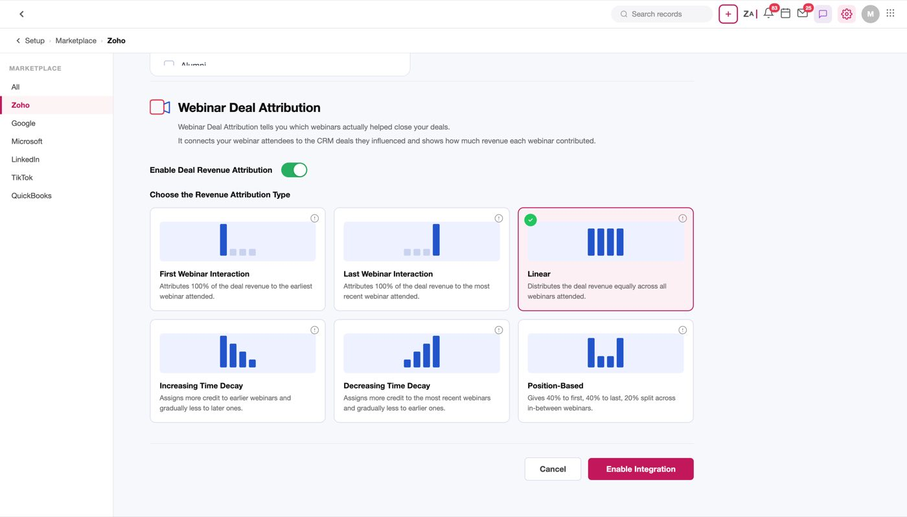
Figure 12 — The six models, each with the A → B → C example that shows what it does to the money
The models themselves are specified in Attribution.

The enabled page
Enable Integration activates the integration and lands on the enabled panel: the same connection details, the sync answer carried across from step 2, the participating modules and the attribution model, with a dirty-state Save bar that appears as soon as anything changes.
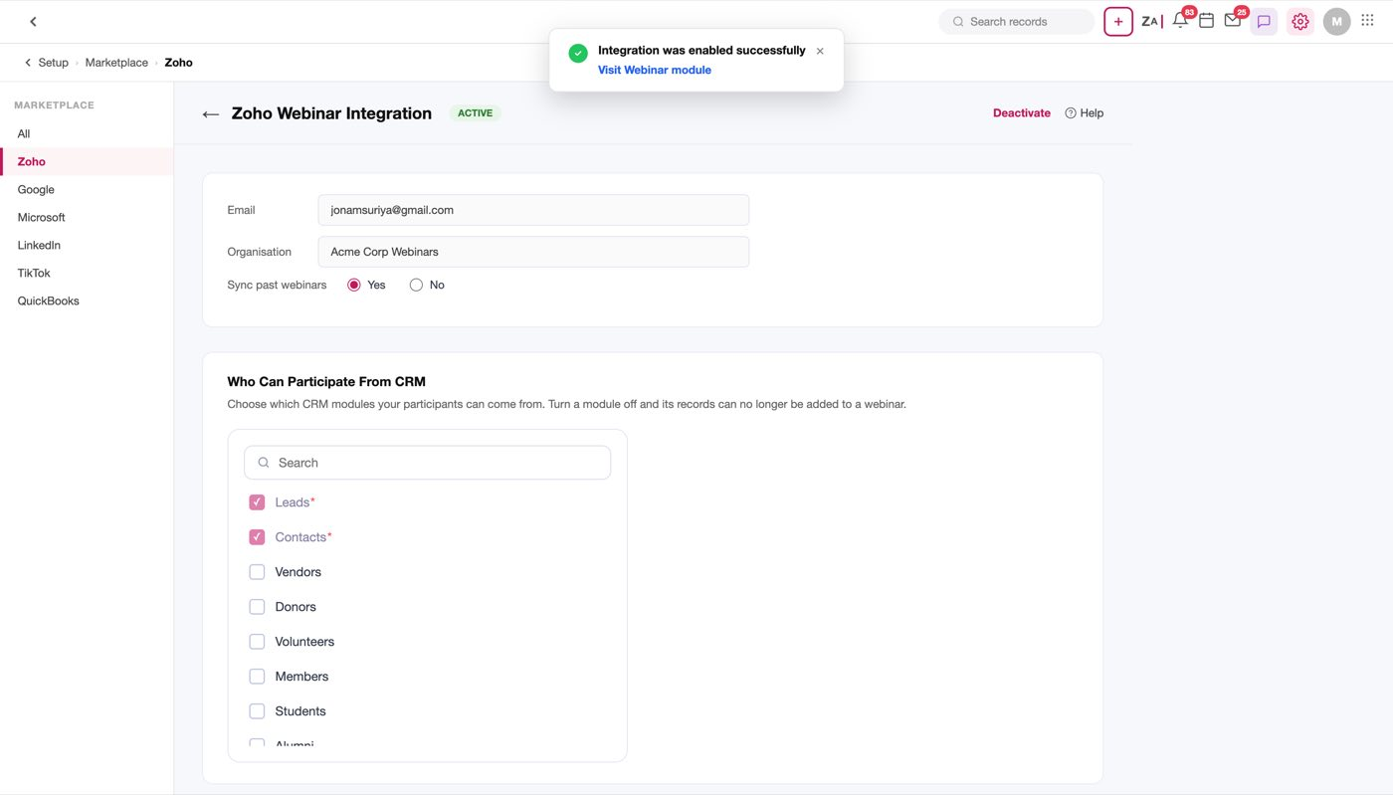
Figure 13 — The enabled panel. Everything set in the wizard is editable here
Open question
Disconnecting is not modelled. The enabled panel has no disconnect or re-authorise action, and mpDisconnectWebinar() only resets the marketplace card's own button. What happens to synced webinars, registrants and attribution figures when an admin disconnects is undecided.

3. Creating a webinar

Where it starts
Once the integration is on, Zoho Webinar is a module in the left nav. Its list view has the standard CRM chrome, and Create Webinar opens a full-page form — not a modal — with Cancel, Save & New and Save at the top right, and Edit Page Layout next to the layout name, because this is a CRM module like any other.
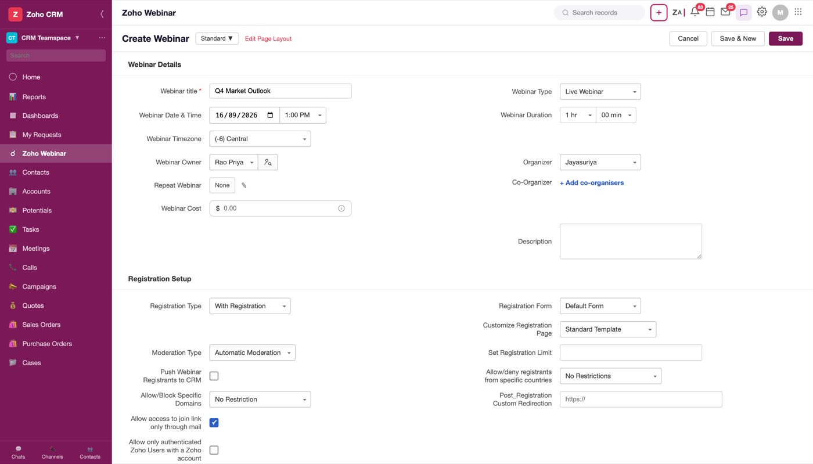
Figure 14 — The create form. Five sections: Webinar Details, Registration Setup, Preferences, Reminders, Follow-Ups
The form has five sections in this order: Webinar Details, Registration Setup, Preferences, Reminders, Follow-Ups. Every field, with its type, default and full option list, is in Appendix A. What follows is only the fields that do something a developer would not guess.

The fields that surprise
Webinar Type is the branch that changes the form. Live Webinar is the default; OnDemand Webinar replaces Webinar Duration with a Video File picker, adds Allow video play/pause, and drops Reminders and Follow-Ups, because there is no start time to remind anyone about. See On-demand webinars.
Webinar Date & Time is a compound control: a native date input and a time picklist inside one bordered box. Webinar Timezone is a row of its own directly beneath it.
Webinar Owner and Organizer are two different things and both are picklists with a search box inside the dropdown. The Owner is the CRM user who owns the record; the Organizer is who runs the session in Zoho Webinar.
Note
The search box inside those dropdowns is why .cs-dd:has(.co-search) sets a min-width — without it the dropdown inherits the button's width and the search field is clipped.

Repeat Webinar opens its own modal (No Repeat / Daily / Weekly / Monthly, with an interval and an end condition) and writes a summary back onto the field. A repeating webinar appears in the list as several rows, one per occurrence.
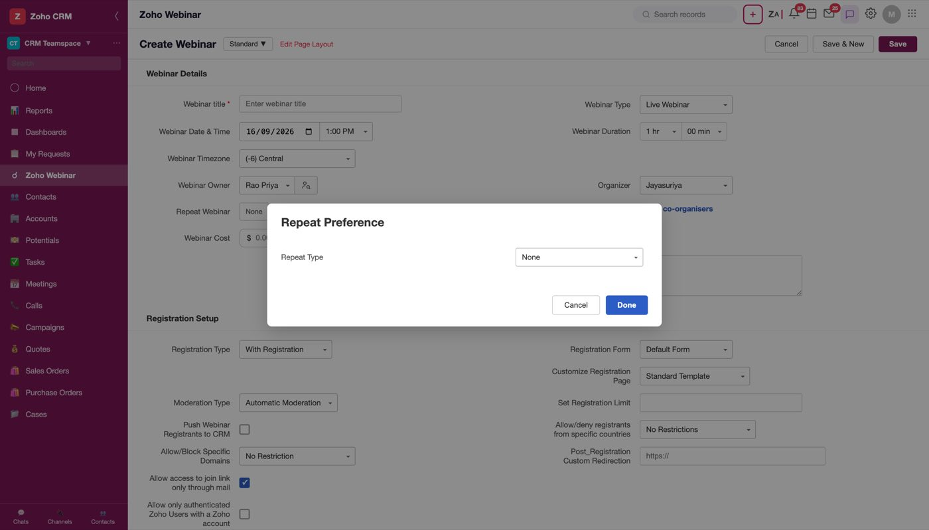
Figure 15 — Repeat Webinar. The summary it writes back is what the list view reads
Webinar Cost looks like a throwaway currency field. It is not: it is the denominator of the entire ROI panel on the completed record. A webinar saved with no cost reports no ROI.
Co-Organizer is not a picklist at all — it is + Add co-organisers, which opens a panel. That is section 4.

Registration Setup
Registration Type decides how much of this section exists. With Registration (default) means people sign up through a form and become registrants; Without Registration means anyone with the link joins, and the section collapses to who-can-join rules and a single thank-you email.
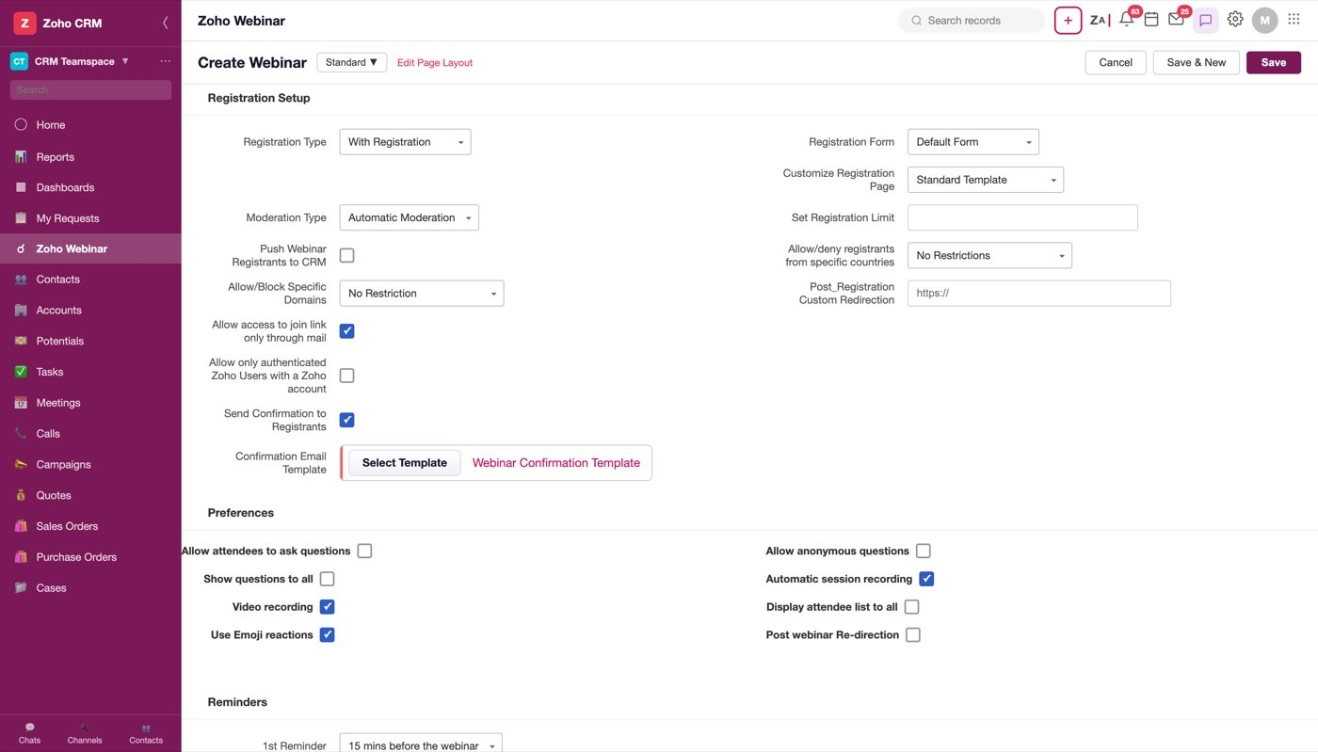
Figure 16 — Registration Setup with registration on
Registration Form is the form registrants fill in. The dropdown lists the saved forms — Default Form, Real Estate Form, Stock Trading Form — each revealing a Preview tag on hover, plus + Create New Form which opens the form builder.
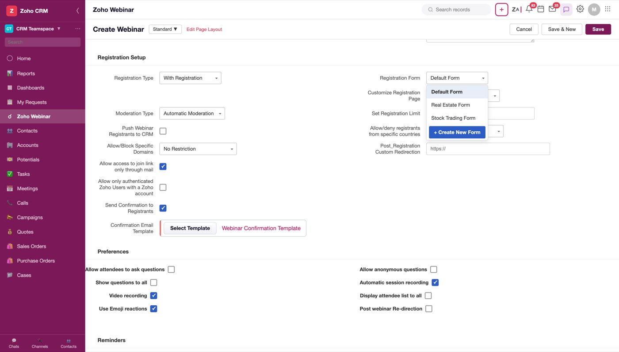
Figure 17 — Each row reveals Preview on hover; the last row creates a new form
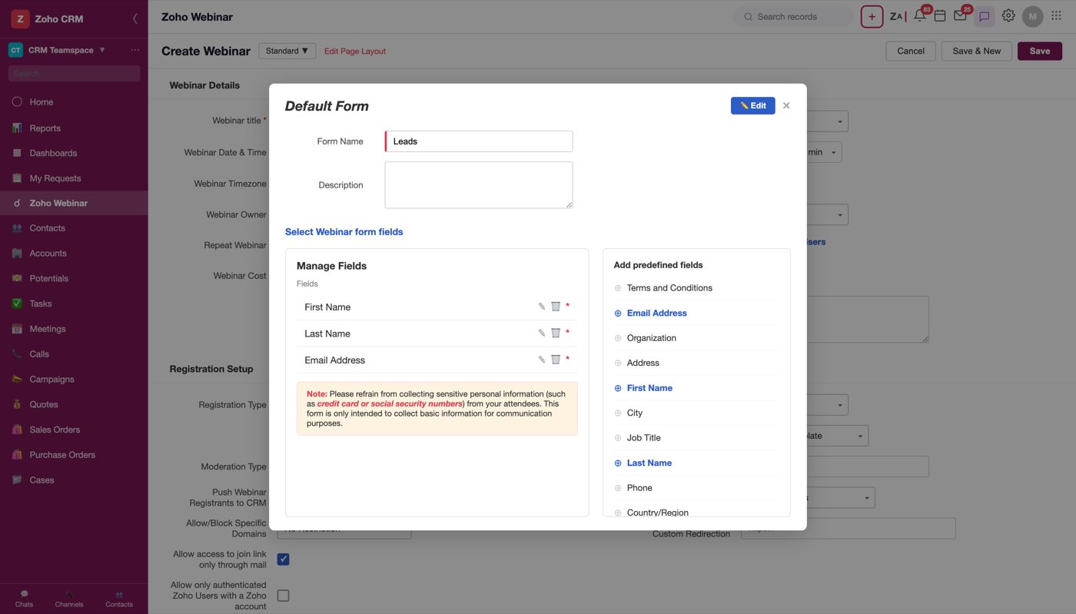
Figure 18 — The preview shows the form's fields read-only, with Edit in the header
Sample use case
Northline's outlook webinar is open to anyone, but their "Portfolio construction for business owners" session is not: they want to know the size of the portfolio before they take the call. That is a second registration form, not a second webinar product — which is why the form is a field on the webinar rather than a global setting.

Customize Registration Page is the field below it, and it is about the page rather than the form — see The registration page.
Moderation Type — Automatic or Manual — is the field that decides whether a queue exists. Manual Moderation is what creates the approve/deny lists that show up on the record after the webinar as Approved / Unapproved / Denied Registrants.
Push Webinar Registrants to CRM is off by default. Turn it on and Manage Configuration appears, which is where the registrant-to-CRM mapping is set: which module a new registrant becomes, which layout, and what to do when the email already exists.
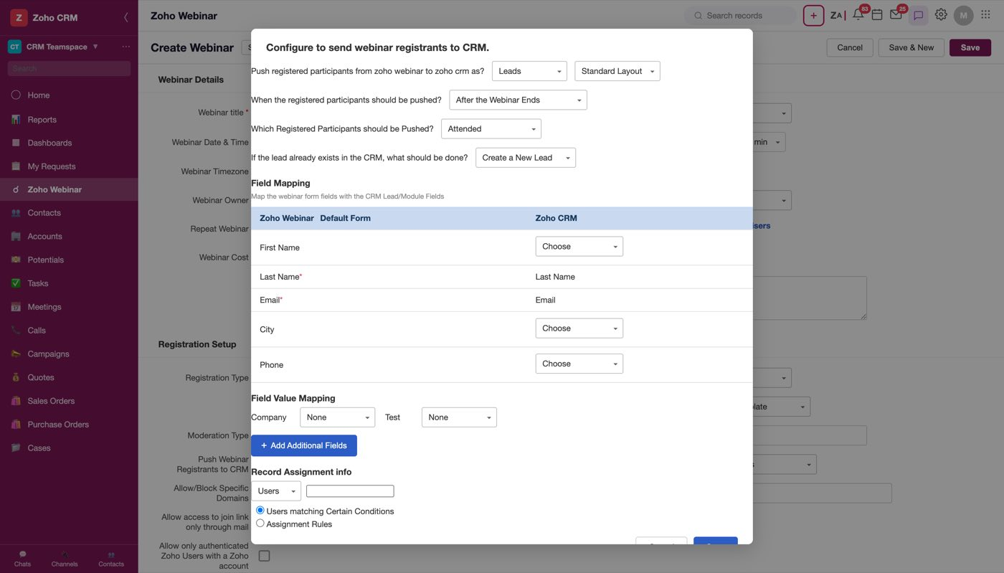
Figure 19 — Manage Configuration. This is the setting that removes the re-import step described in the introduction
The rest of the section is access control: country allow/deny, domain allow/deny, join-link-only-through-mail (on by default), authenticated-Zoho-users-only (off), a registration limit, and a post-registration redirect URL.

Preferences, Reminders and Follow-Ups
Preferences are the in-session switches — questions, anonymous questions, showing questions to all, automatic session recording, video recording, the attendee list, emoji reactions, post-webinar redirection.
Reminders and Follow-Ups are the email schedule. The 1st Reminder defaults to 15 mins before the webinar; the 2nd and 3rd default to None, and their option lists are the same eleven intervals plus None — so a webinar can legitimately send one reminder, or three. Follow-ups default to 2 mins after the webinar ends for both attendees and absentees, each with its own template slot and an Include Recording checkbox.
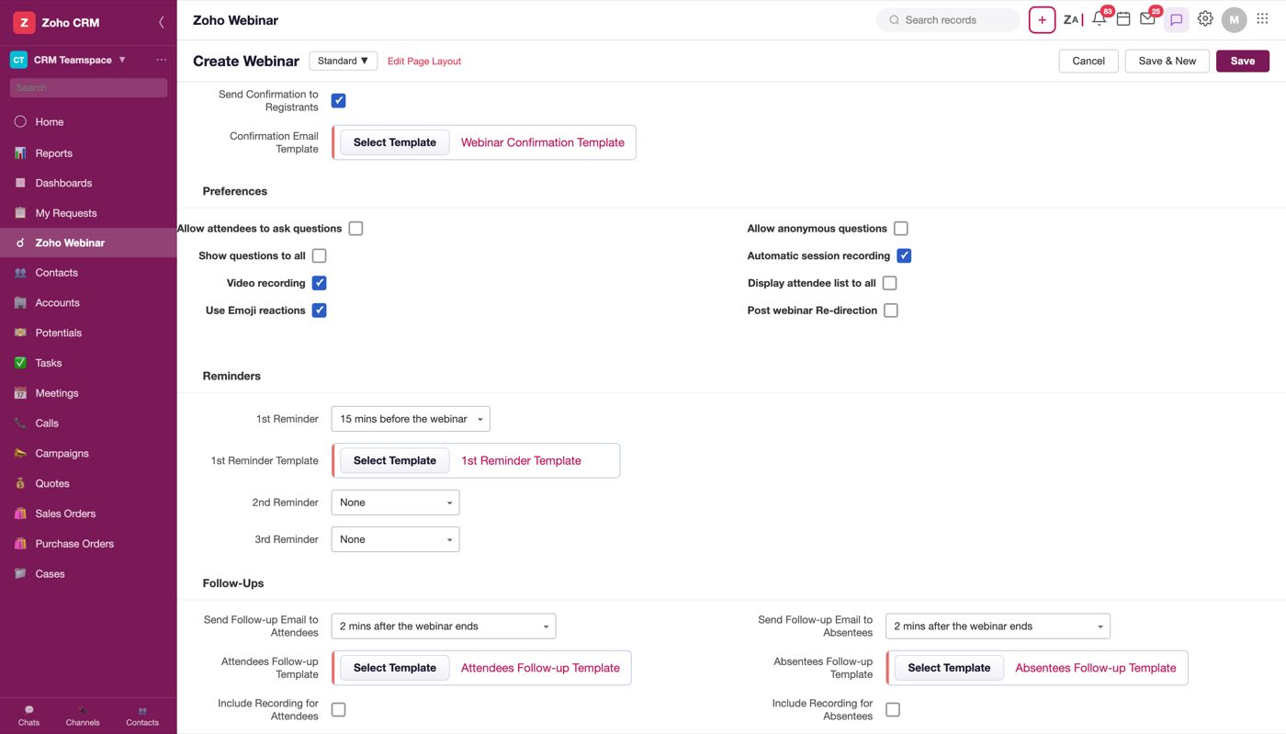
Figure 20 — Preferences, Reminders and Follow-Ups all fit in one screenful of the form's scroll
Every template slot here works the same way: a Select Template button and, beside it, the currently chosen template as a link that previews it.
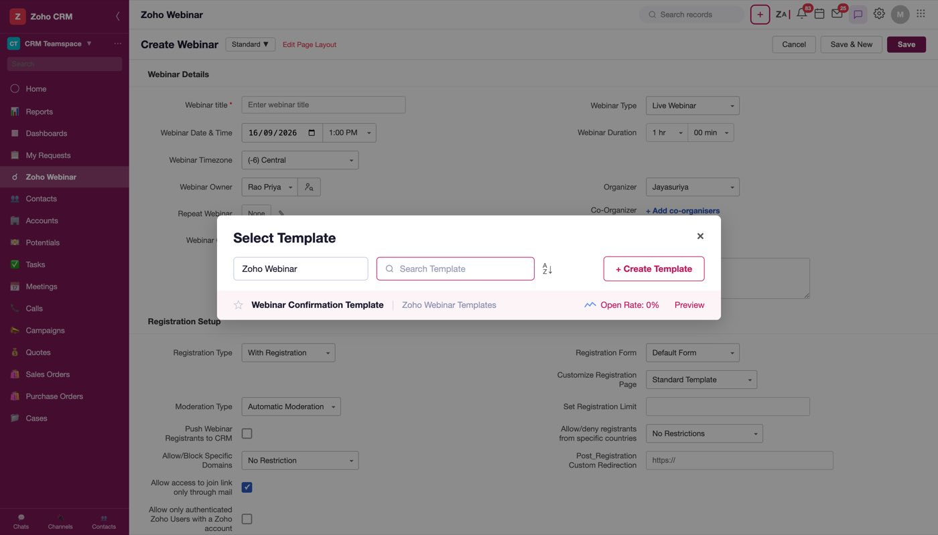
Figure 21 — A slot's Select Template dialog. The folder dropdown is a static "Zoho Webinar" label — every template it lists is a webinar template, so there is nothing to filter

What blocks a save
Webinar title is the only hard requirement on the form. Saving without it outlines the field and shows "Webinar title cannot be empty" underneath it; the message clears as soon as you type.
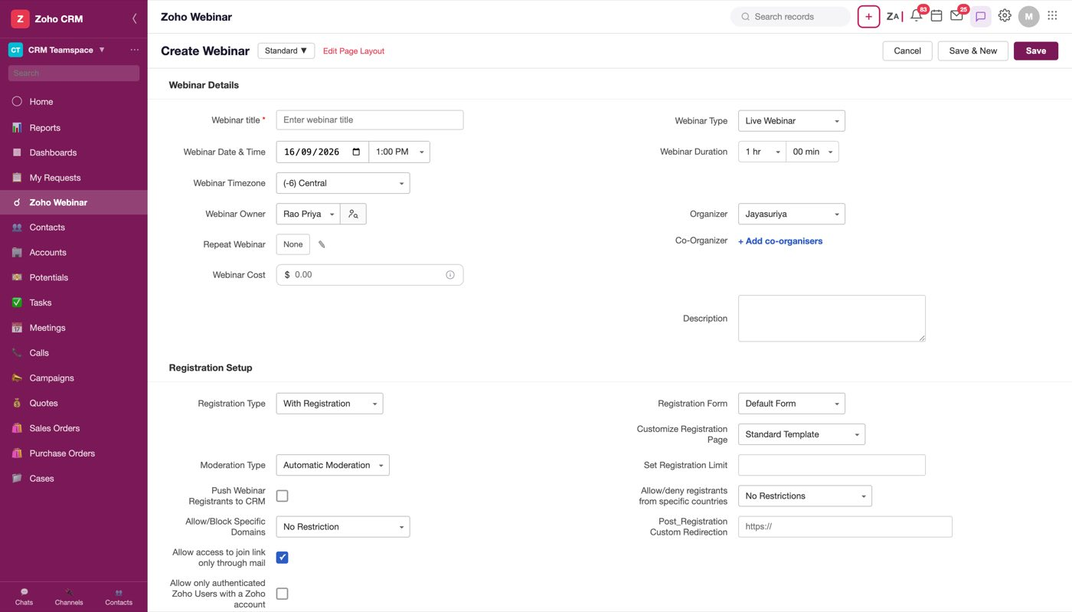
Figure 22 — Save with no title. The message is inline, under the field
Open question
Nothing else is validated in the mock — not the date being in the past, not a registration limit of zero, not a cost that isn't a number, not an on-demand webinar saved with no video file. Which of those should block a save is undecided.

4. Co-organisers
A webinar can have more than one host, and the second host may be a CRM user, a Zoho Webinar user, or somebody who is in neither system yet. The field reflects that: it is not a picklist but an action.
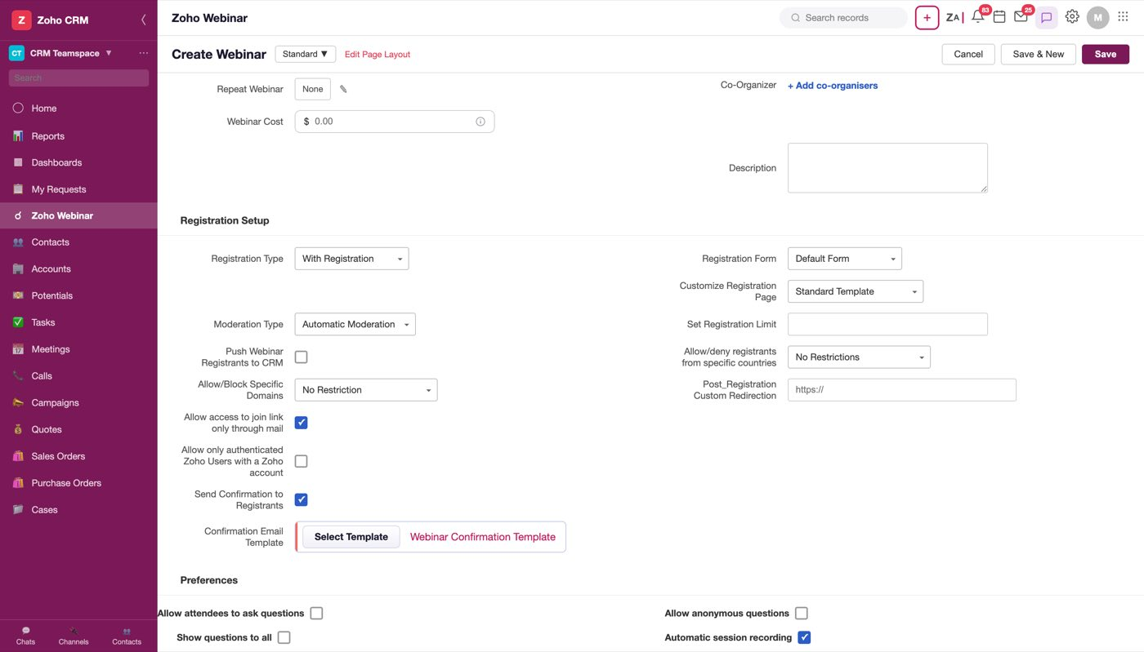
Figure 23 — The field reads + Add co-organisers until something is selected
Clicking it opens the Add Co-organisers panel:
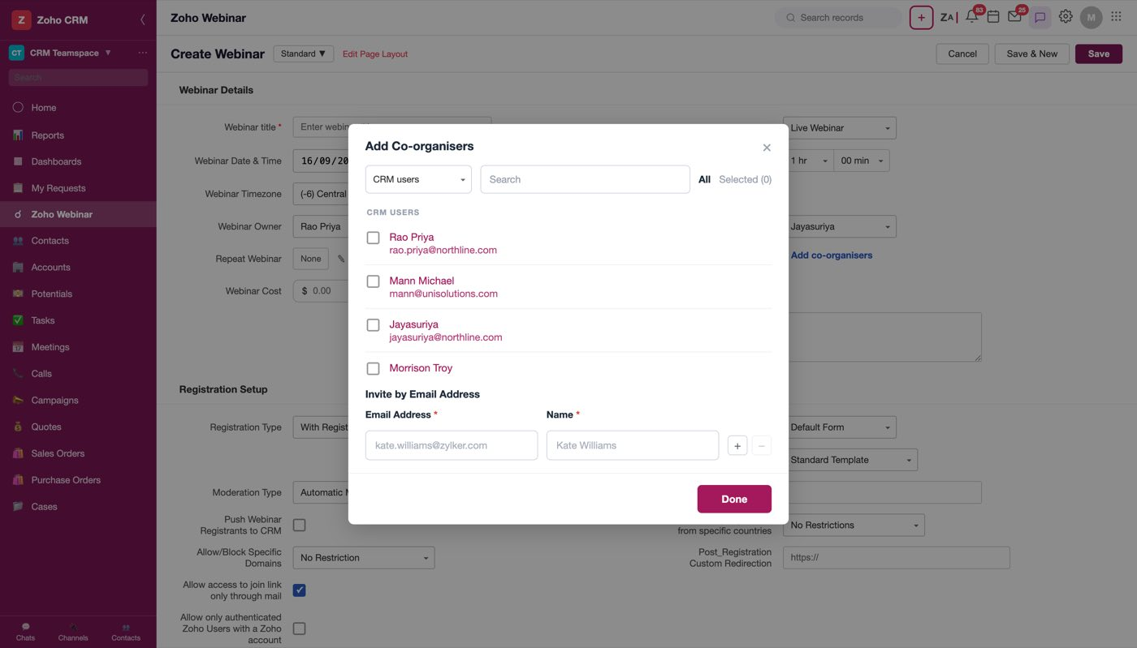
Figure 24 — The panel. Source picklist, search, All / Selected tabs, the directory below, and the invite-by-email block at the foot
The source picklist chooses which directory you are looking at — CRM users or Webinar users — and the list below is grouped under that name.
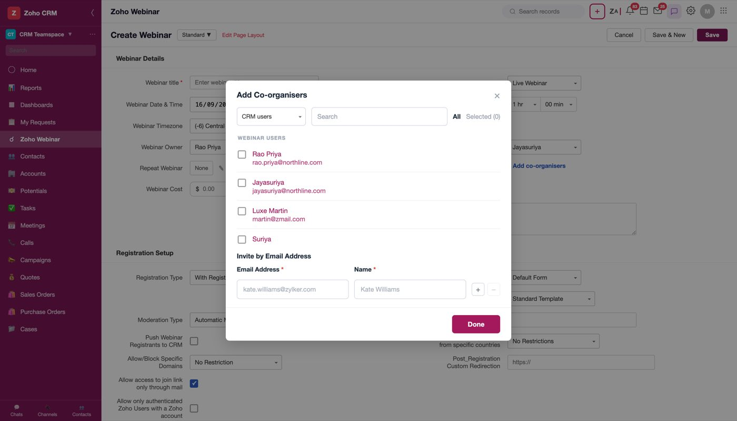
Figure 25 — Switching the source switches the group heading and the people under it
Search filters the directory that is showing.
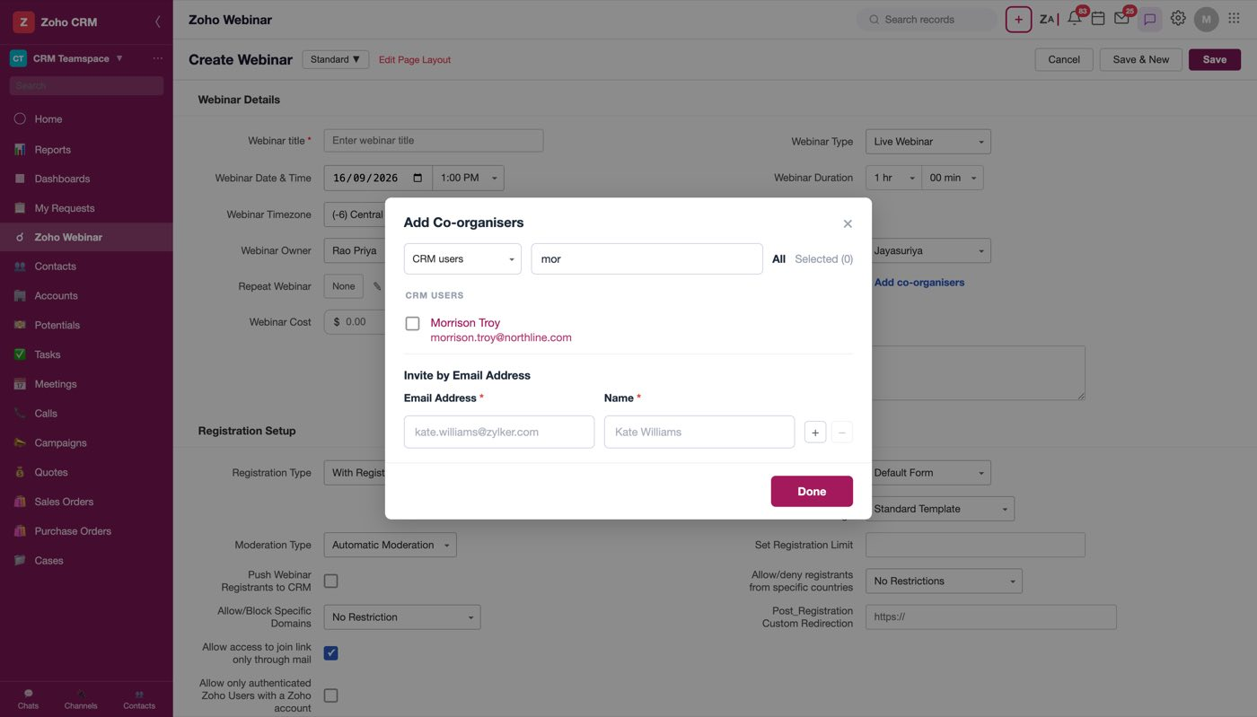
Figure 26 — Search narrows the list in place
All / Selected (n) are two views of the same panel. Selected lists everyone chosen across both directories together, because after picking from both you want one list to check rather than two tabs to flick between. Anyone invited by email appears under their own Invited by email group so they are not mistaken for a directory user.
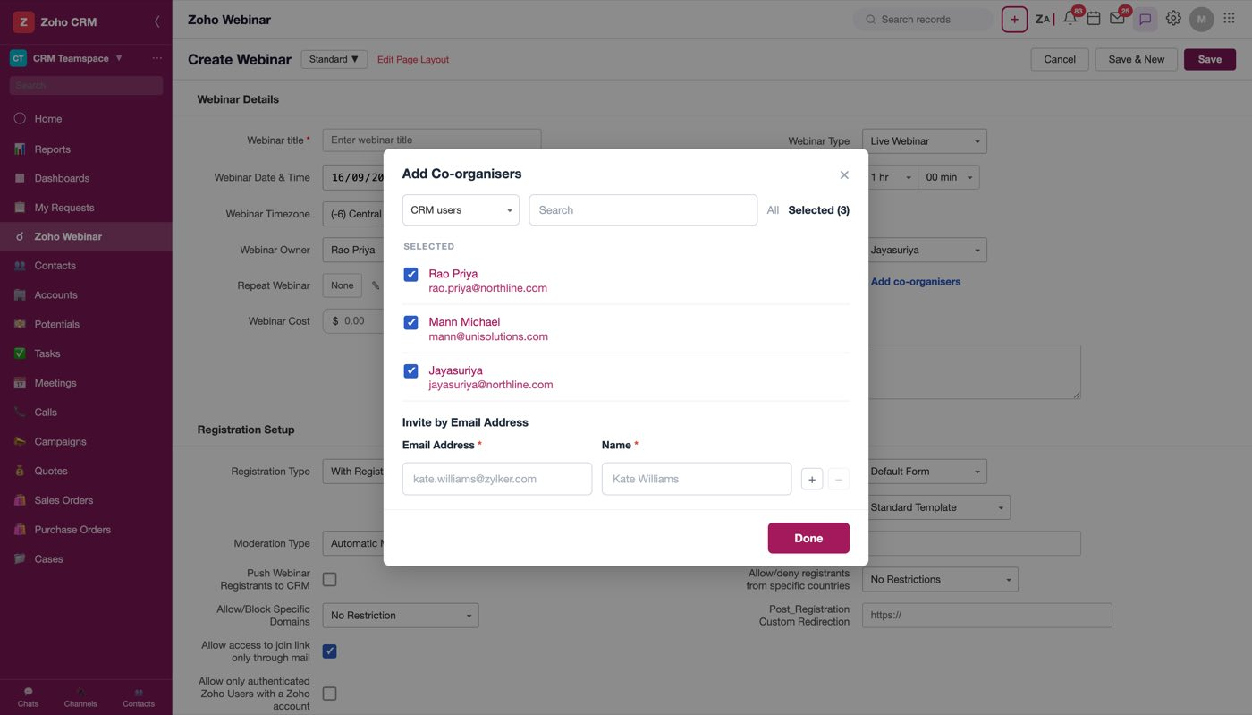
Figure 27 — Selected (3) — the tab label carries the count
Invite by email address is for the person who is in neither directory. There is no Invite button: each invitation is a row of Email Address \* and Name \* with + and − beside it. + inserts another row below and focuses it; − removes that row and is disabled on the only row, since there would be nothing left to type into.
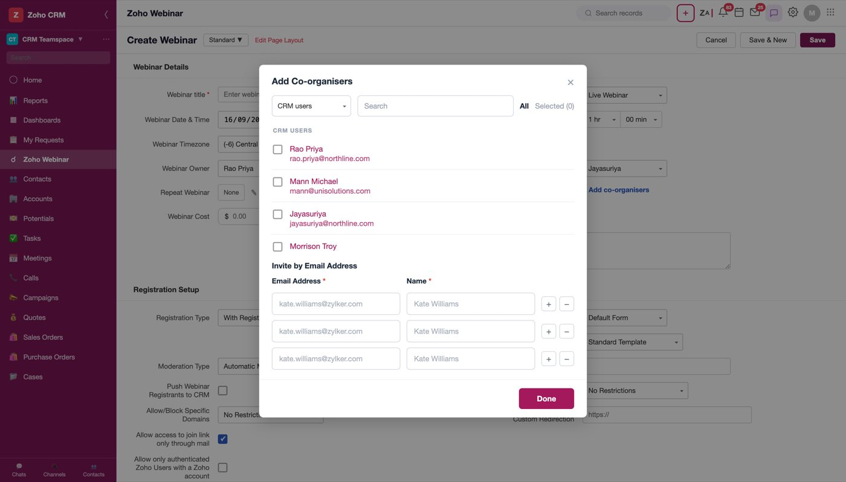
Figure 28 — Three invitation rows after two +. The − on a single row is disabled
Rows are read when Done is pressed, so there is no separate commit step to forget. A half-filled row keeps the panel open and says why — "Enter a name for kate.williams@zylker.com." A name is required rather than optional on purpose: a bare address is not recognisable in a list of co-organisers six weeks later.
The same person can exist in both directories — that is the ordinary case for anyone who runs webinars, and the mock's directories overlap on Rao Priya and Jayasuriya to make it reachable. Both copies are tickable; the clash is caught on Done, which keeps the panel open and shows "Duplicate exists: rao.priya@northline.com has been added twice." The same check covers a typed invitation whose address matches somebody already selected.
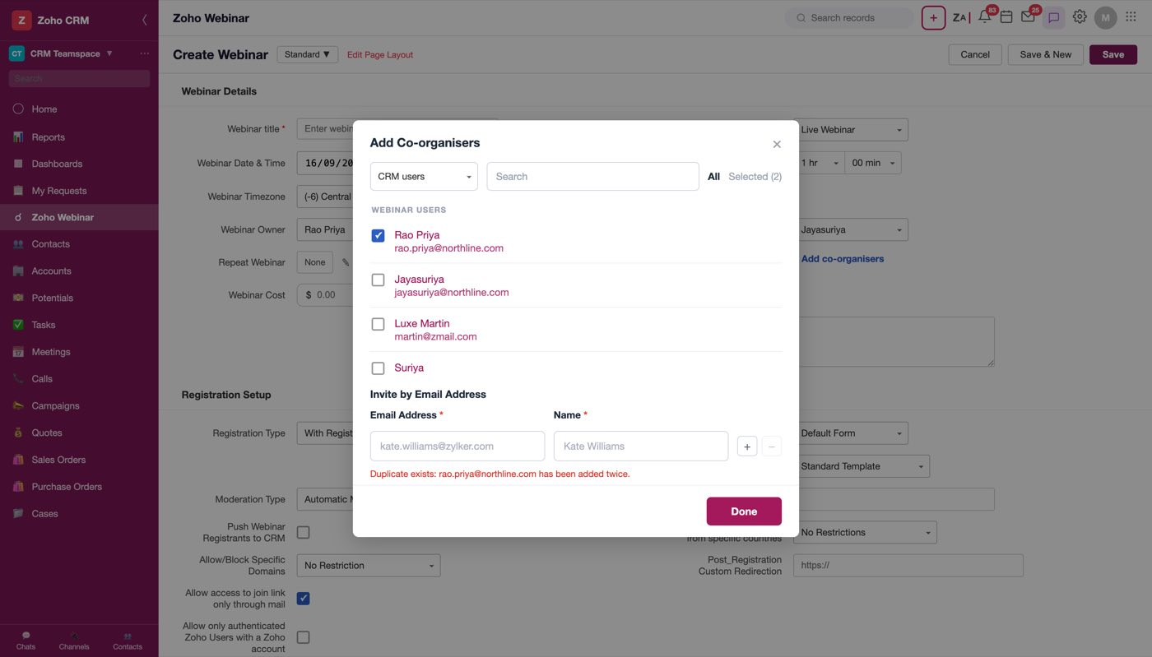
Figure 29 — One person picked from both directories. Done refuses until one of the two is removed
Note
Identity inside the panel is the directory entry (src|email), which is what makes two copies of one person two separate selections rather than one silently de-duplicated row. Identity for the duplicate check is the email address alone. Both behaviours are deliberate and the pair is what produces the error above.

Once anything is selected, the field reads Manage co-organisers rather than the names, with the full list on its title.
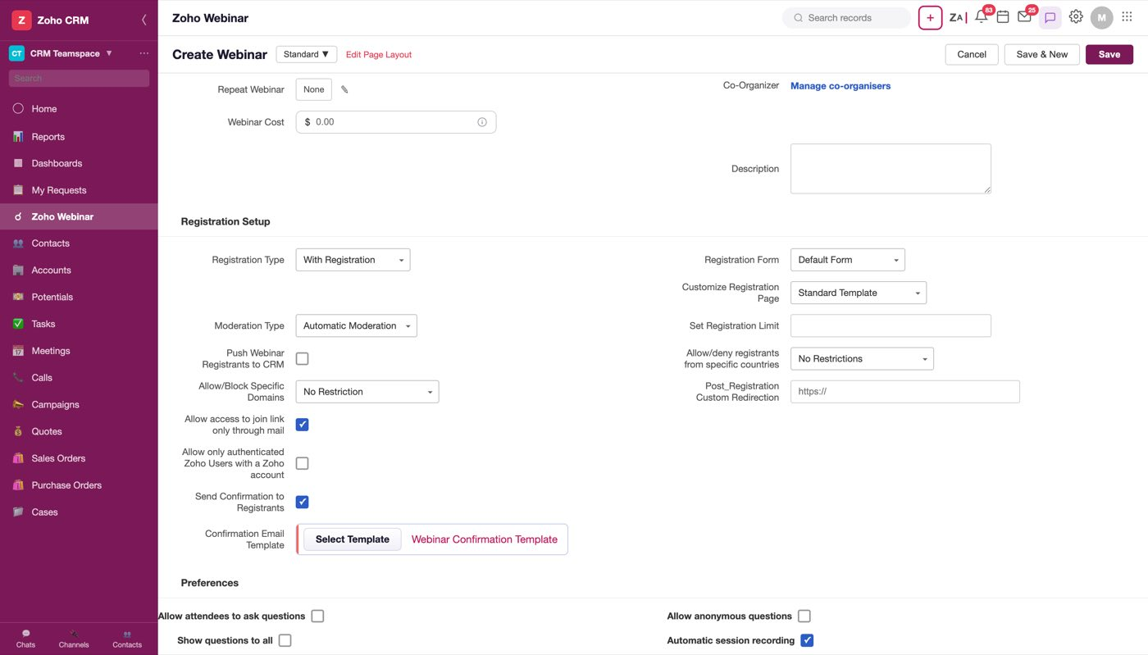
Figure 30 — After Done. "Manage" rather than "Add", because there is now something to manage
Selection is stored on the field itself as hidden chips carrying name, email, source and whether the person was invited; the panel reads them on open and writes them on Done, which is what makes Cancel genuinely discard.
Open question
What a co-organiser can actually do is not modelled — whether they can edit the webinar, start it, see registrants, or appear on the registration page. And an invited co-organiser's email is never sent anywhere in the mock: there is no invitation email template for it.

5. The registration page
The registration form is the fields somebody fills in. The registration page is what that form is wrapped in — the branded page a registrant actually lands on from the link you publish. They are two different fields, one under the other.
Customize Registration Page is a picklist with two options, Standard Template (default) and Custom Created. Hovering either option reveals an eye, and the eye previews that page as a registrant sees it. It previews without selecting: the click is stopped before it reaches the option.
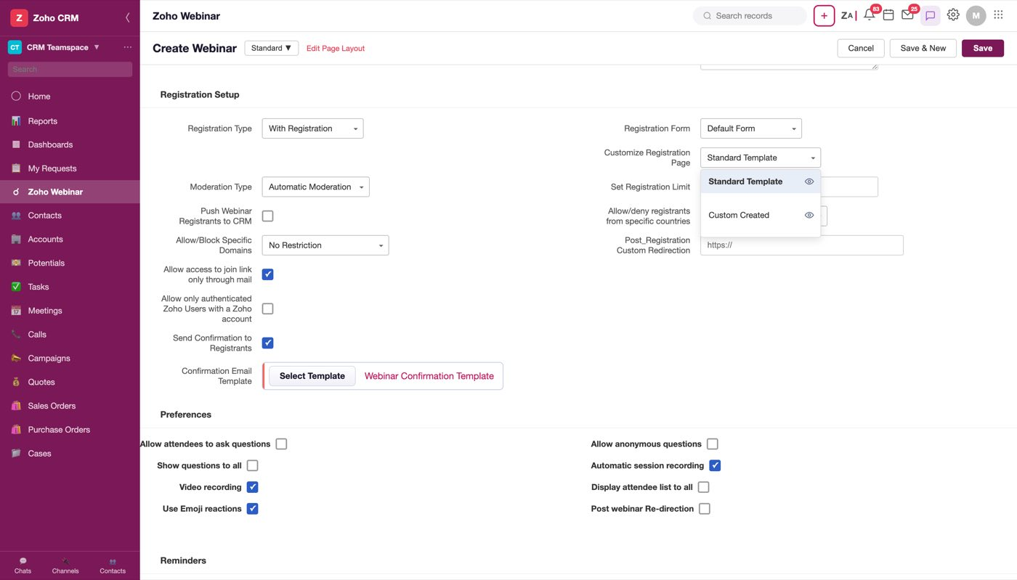
Figure 31 — The eye appears on the hovered row. Clicking it previews; clicking the label selects
The preview is a full-screen render of the public page — the webinar title in the bar, a desktop/mobile toggle, the branded card, the session details and countdown on the left, the registration form on the right with the consent line and Register, and the footer.
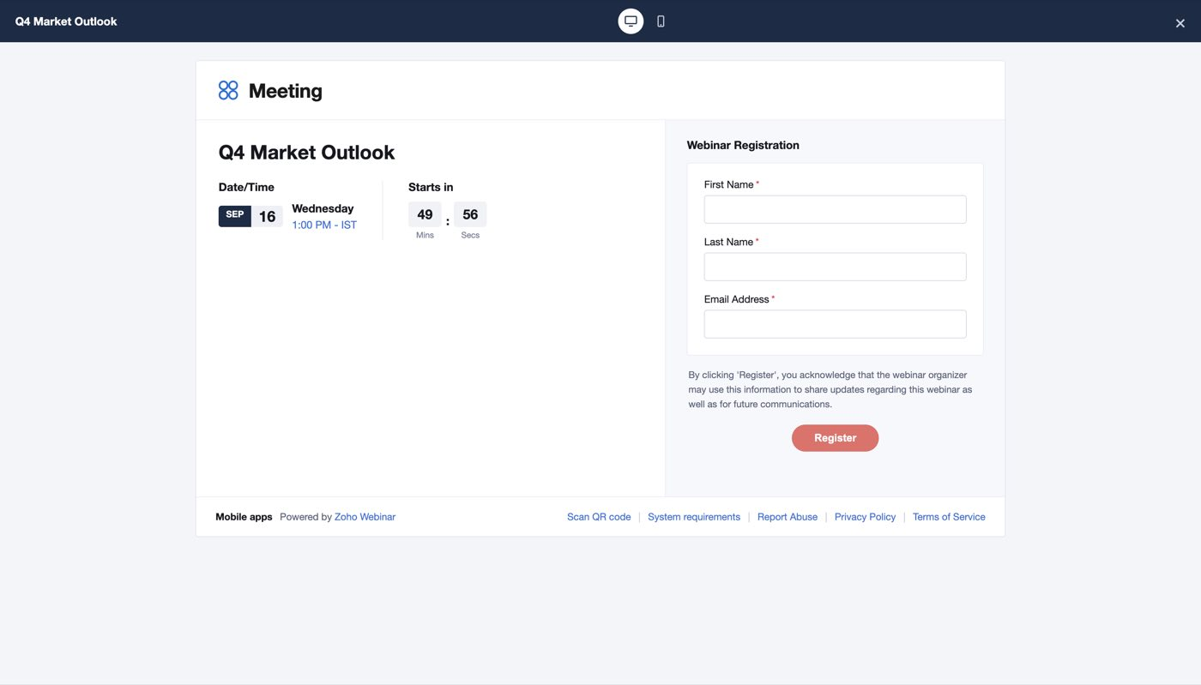
Figure 32 — Standard Template. Note the title, date and time are the ones being set on the form, not sample text
The two layouts differ in the fields they carry:
 | Standard Template | Custom Created
First Name | required | required
Last Name | required | required
Email Address | required | required
Phone Number | — | required
Company | — | optional
Portfolio Size | — | optional

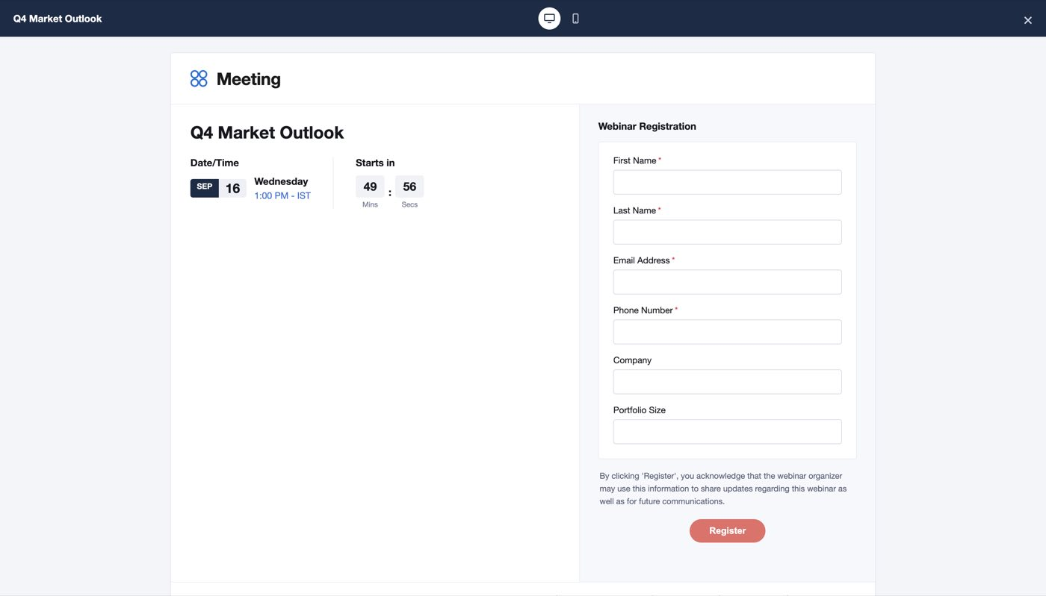
Figure 33 — Custom Created adds the three extra fields
The toggle in the bar switches the same page to the mobile width, which stacks the two columns.
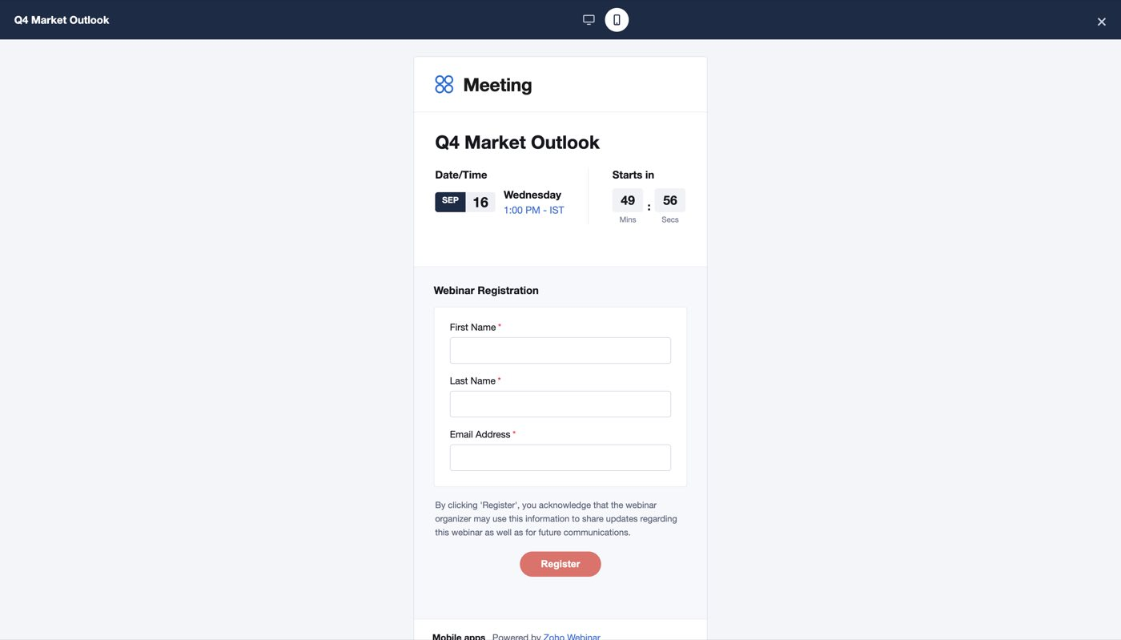
Figure 34 — The mobile view of the same page
Open question
"Custom Created" is presented as a single option, but a customer will have more than one custom page. Whether this picklist should list saved page templates by name (the way Registration Form does), and where a custom page is authored, is undecided. The mock has no builder behind it.

Open question
The two fields overlap: the registration form already defines the fields, and the page preview shows a field set of its own. Which one wins when a Real Estate Form is selected alongside a Standard page needs deciding before this is built.

6. The webinar list
The module's list view is a CRM list like any other — view selector, column headers with sort, the standard toolbar.
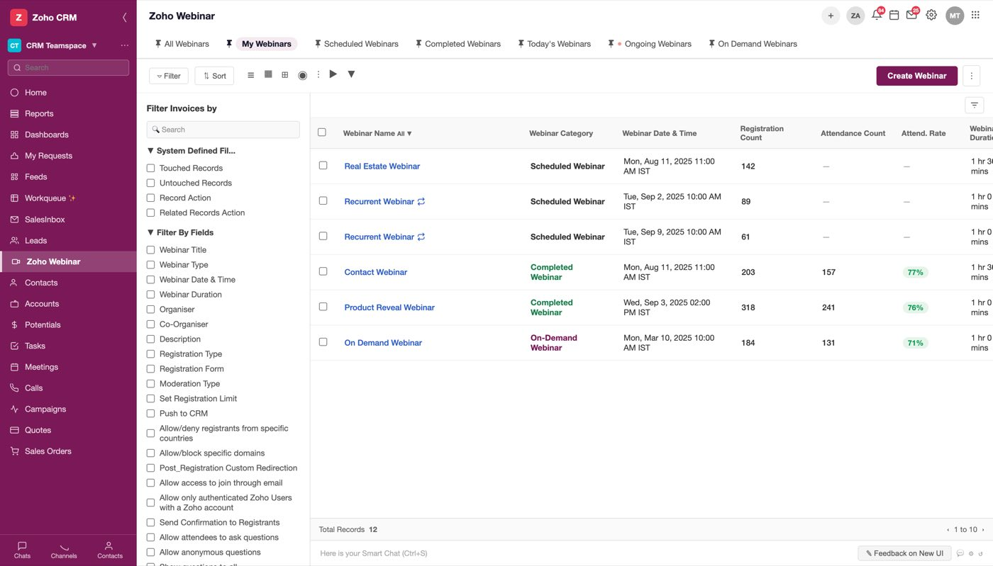
Figure 35 — The list. Webinar Category is the state, Webinar Type is the kind; the two are easy to confuse
Column | What it holds
Webinar Name | Record name, links to the detail page
Webinar Category | The state: Scheduled Webinar, Completed Webinar, On-Demand Webinar
Webinar Date & Time | Start, with timezone
Registration Count | Registrations so far — populated before the webinar too
Attendance Count | Blank (—) until the webinar has run
Attend. Rate | Attendance ÷ registration, blank until completed
Webinar Duration | e.g. 1 hr 30 mins
Organiser | Who runs it
Webinar Type | Live Webinar / On-Demand Webinar

Two reading rules a developer needs:
- Category and Type are different columns. Category is the lifecycle state; Type is Live vs On-Demand. An on-demand webinar reads On-Demand Webinar in both, which is why they look redundant until you see a completed live one.
- A repeating webinar is several rows, one per occurrence, sharing a name and differing by date — Recurrent Webinar appears twice in the sample data with different dates and registration counts.

7. A webinar that hasn't happened yet
This is the record state you will spend the most time on, because it is where everything is collected.
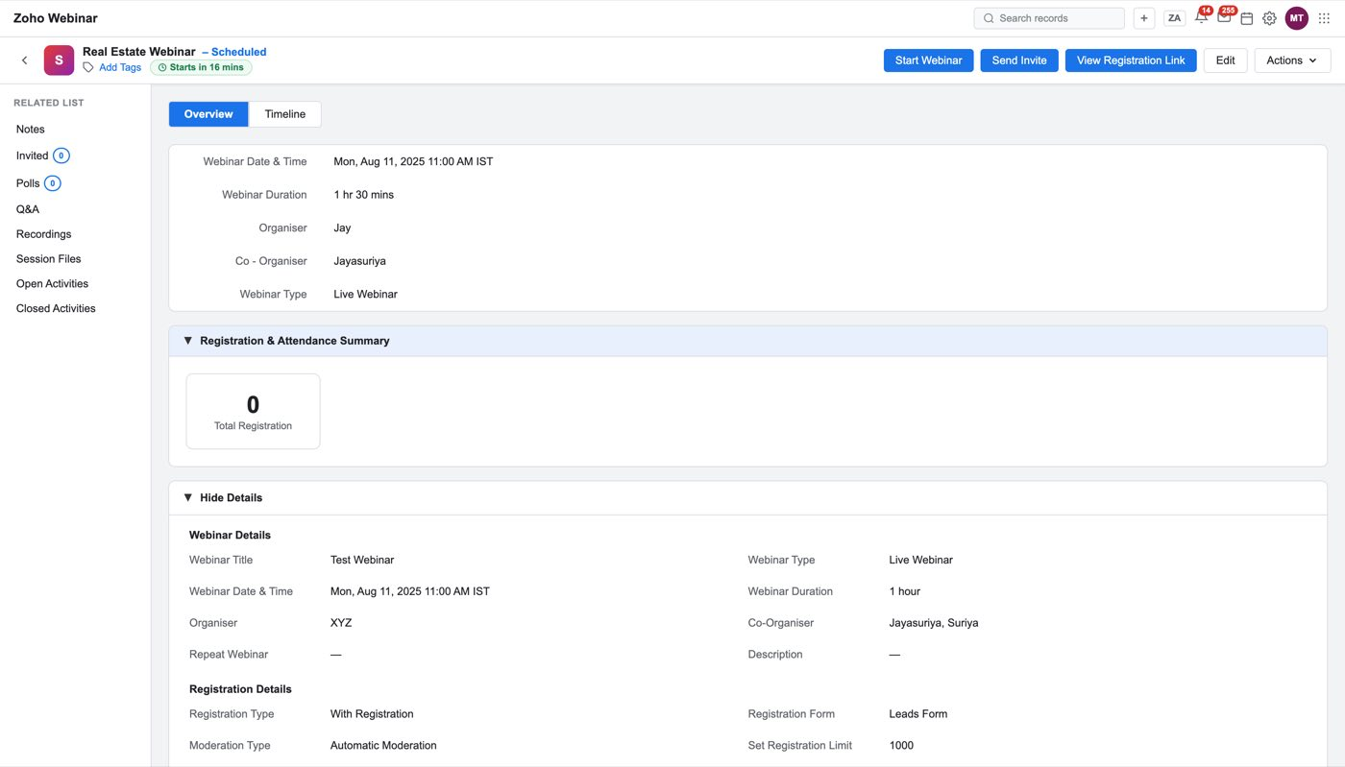
Figure 36 — A scheduled webinar with nothing in it yet. The status pill next to the title reads "Starts in 16 mins"
The header carries the actions: Start Webinar, Send Invite, View Registration Link, Edit, and an Actions menu. The left rail is the related-list index — Notes, Invited, Polls, Q&A, Recordings, Session Files, Open Activities, Closed Activities — and the counts on it are the fastest read of what the record holds.
Below the summary is the Details panel: everything set on the create form, in two columns, under Webinar Details and Registration Details.
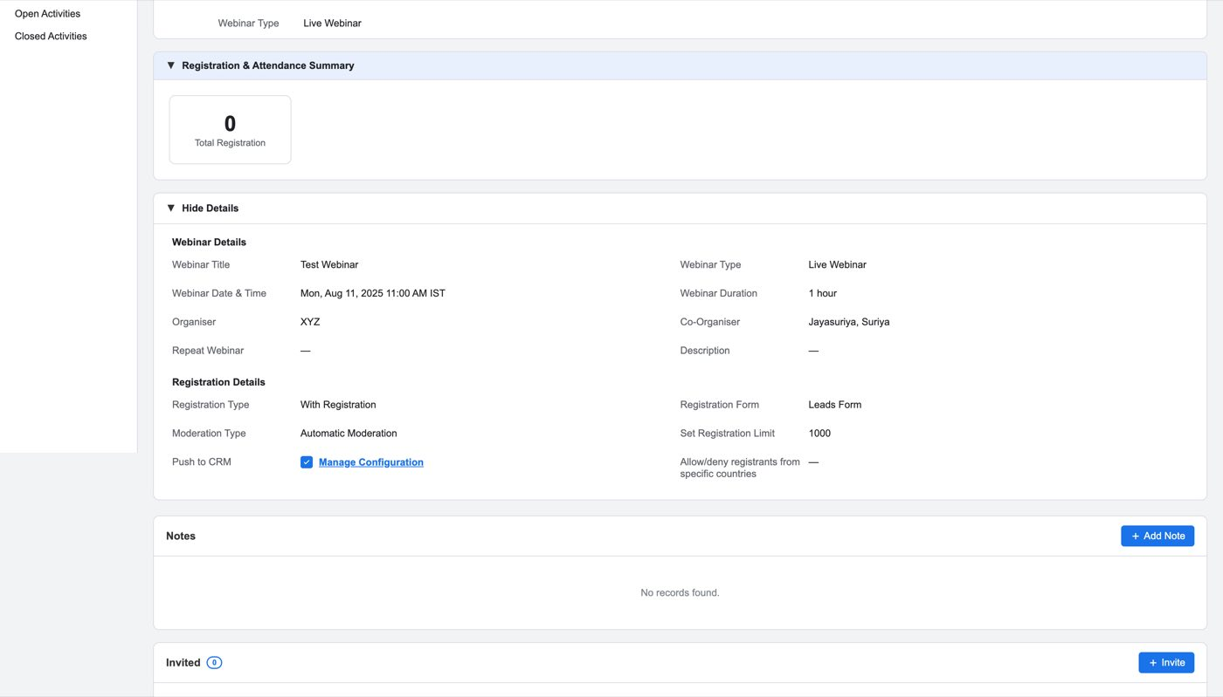
Figure 37 — The Details panel is the create form's answers, read-only
Note
Mock defect, do not copy. The Details panel is hardcoded sample content — it reads Test Webinar, organiser XYZ, Leads Form, limit 1000 on every record, whichever row you opened. Populate it from the record.

Send Invite
Send Invite is the flow that makes this integration worth building: it invites CRM records, from the modules the admin allowed in setup, without an export.
Step 1 — pick the records. A module dropdown, a view filter, a search box, the standard CRM filter sidebar, and the records with checkboxes. Create Lead sits top right for someone who isn't in CRM yet, and Invite Additional Recipient Via Email: Add Email_ID at the foot covers an address with no record at all.
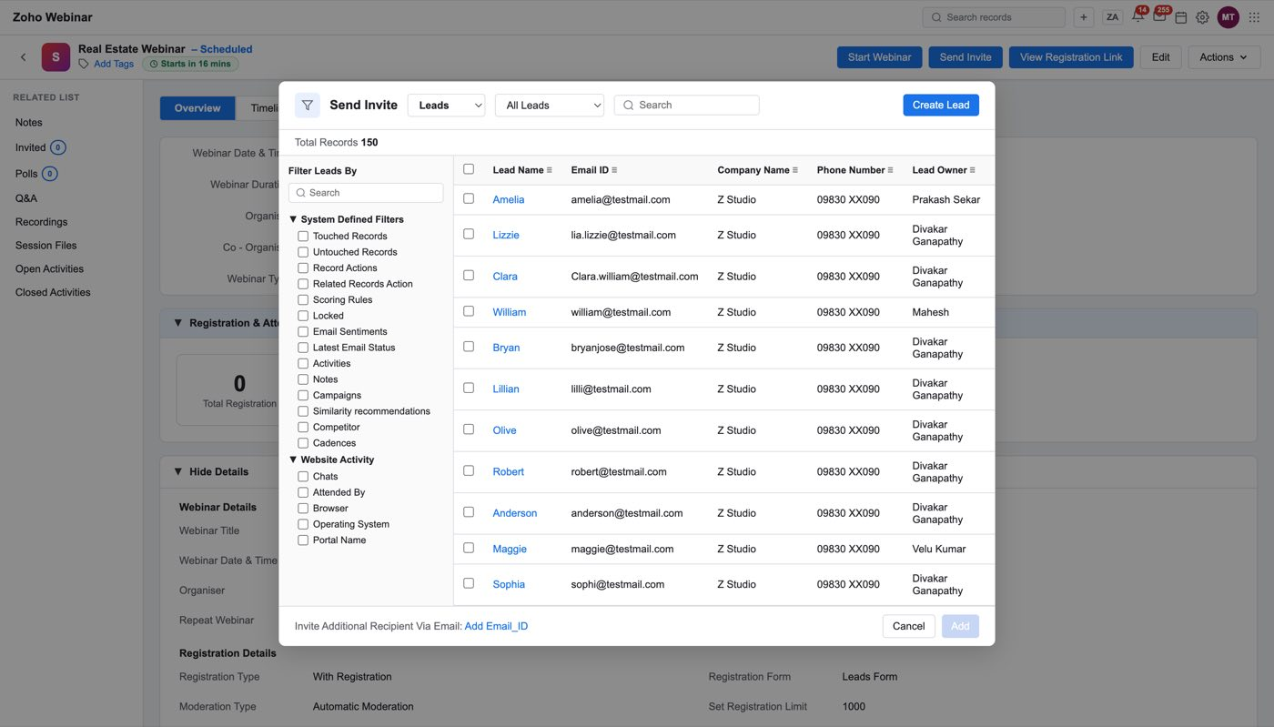
Figure 38 — Step 1. The module dropdown only offers what Who Can Participate From CRM allows
Step 2 — confirm the list. Add commits the ticked records and moves to a confirmation step that shows the breakdown by module, with Remove ALL and Next.
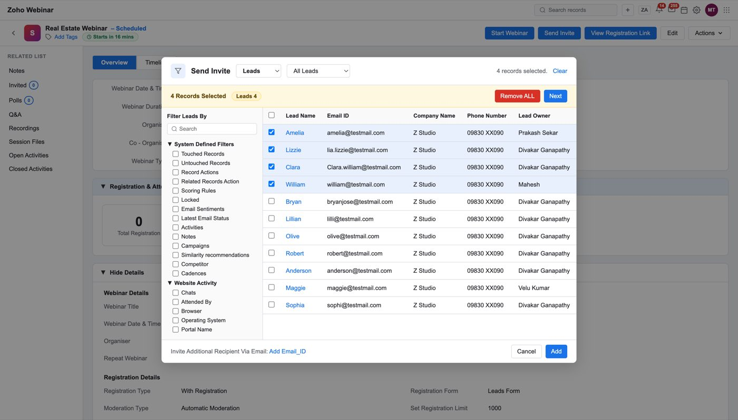
Figure 39 — Step 2. The module breakdown is how you catch having grabbed the wrong view
Step 3 — Mass Email. Next opens Mass Email: the recipient summary, the template, and the send option (immediately, or Schedule Later). The template is chosen through Select Template, with the current choice beside it as a link that previews it. A daily send counter — "Emails sent today: 0 / 1000" — sits in the footer.
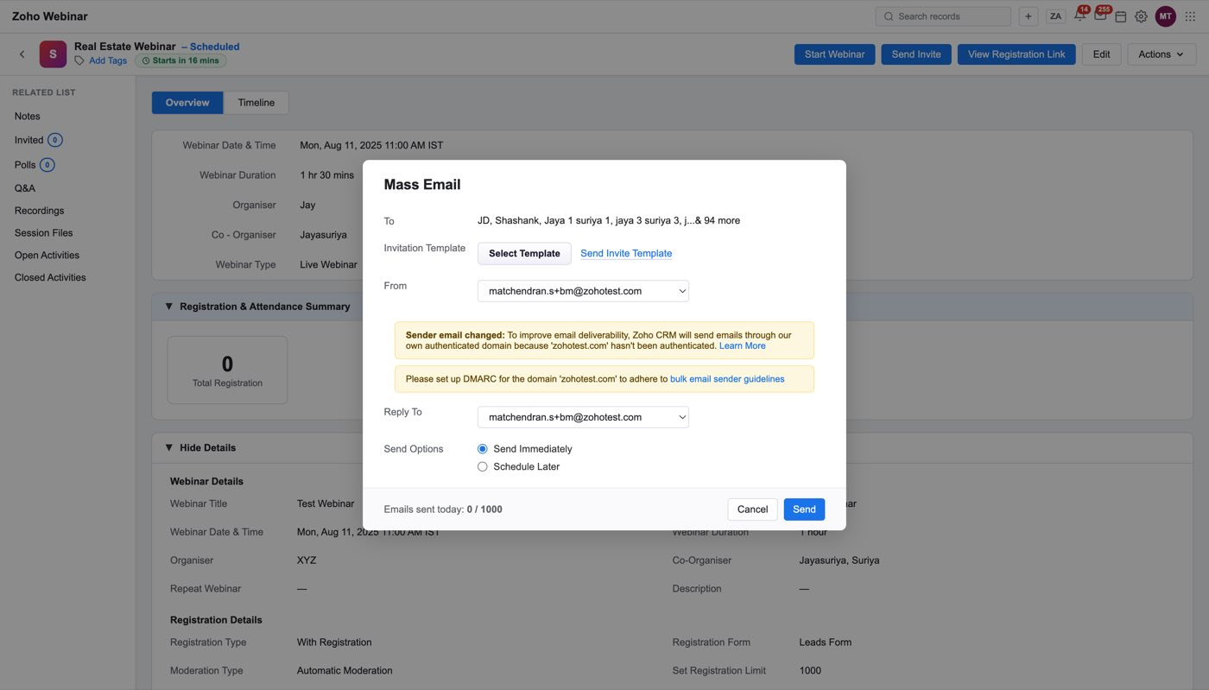
Figure 40 — Mass Email. Note the To line collapses to "…& 94 more"
Select Template here lists only invitation templates — the Invitation-type rows from Setup ▸ Templates, nothing else, because every email this step can send is an invitation.
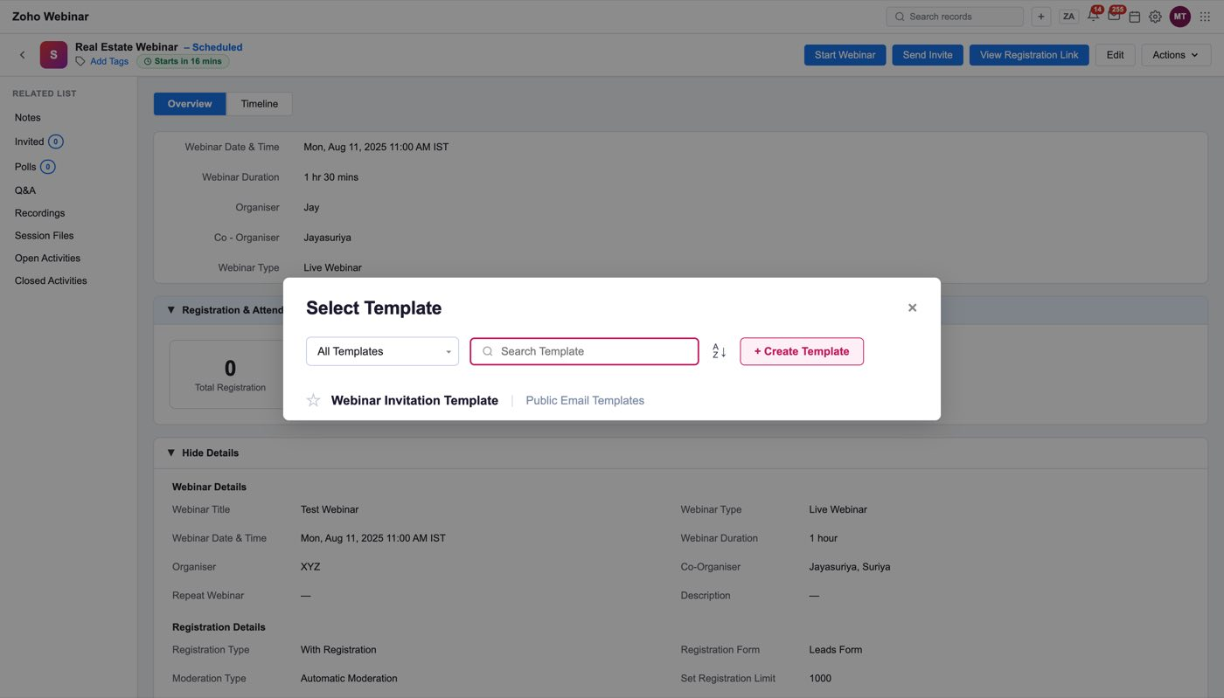
Figure 41 — One row, because one invitation template exists. The second column is the folder, not the module
Send sends, and three things happen at once.
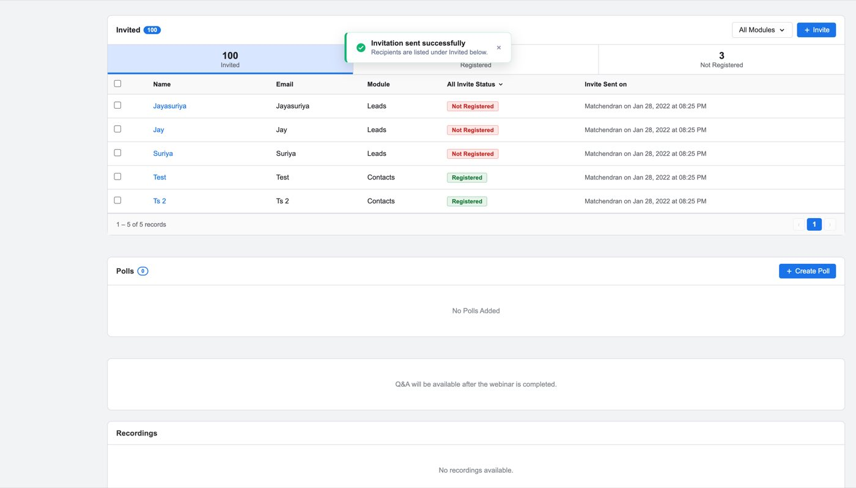
Figure 42 — "Invitation sent successfully — Recipients are listed under Invited below."
First, the toast. Second, the recipients appear under Invited, each with their module, invite status and when the invite was sent, and the strip above the table splits them into Invited / Registered / Not Registered.
Figure 43 — The Invited related list after a send. Everyone starts Not Registered
Third — and this is easy to miss — an Email source-tracking link is created. Before the first invite, View Registration Link holds the default link and nothing else, with source tracking off:
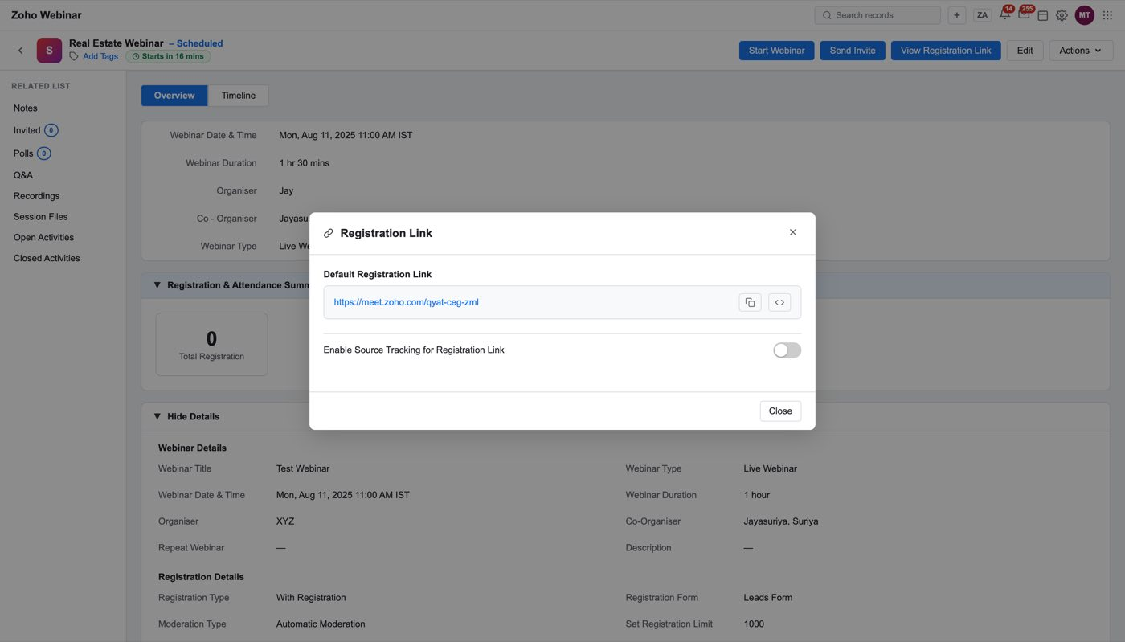
Figure 44 — Before any invite: the default link, tracking off, no table
After the send, tracking is on and the table holds an Email row, created by the user who sent, with its own visited and registered counts:
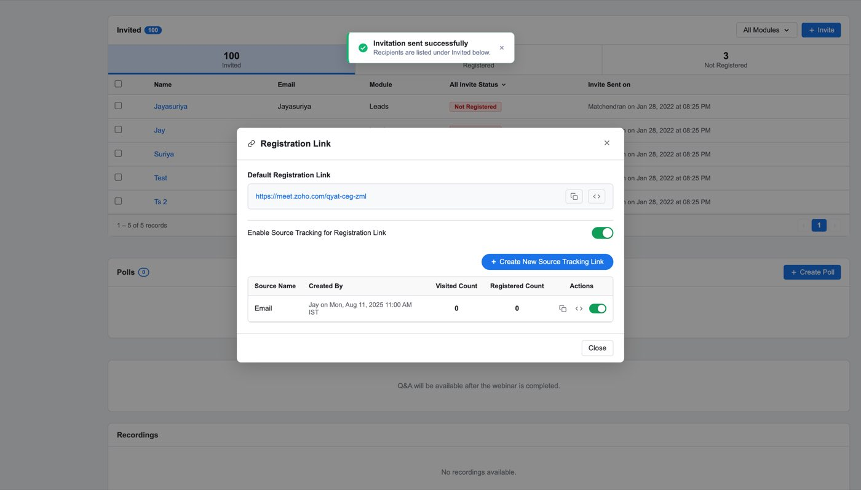
Figure 45 — After the send. The channel CRM invites arrive through is now tracked like any other source
Note
That is what makes "Registration by Source" on the completed record able to say Email at all. A source row is created once — sending a second batch does not add a second Email row.

Re-inviting
Anyone in the Invited list who has not registered can be invited again, either per person or per module, from the same Mass Email screen (isReInvite). The difference is that the template starts empty rather than defaulting to the invitation template, so a second nudge is not silently identical to the first.

Polls before the webinar
Polls are written in advance. Create Poll takes a question, a type and the options.
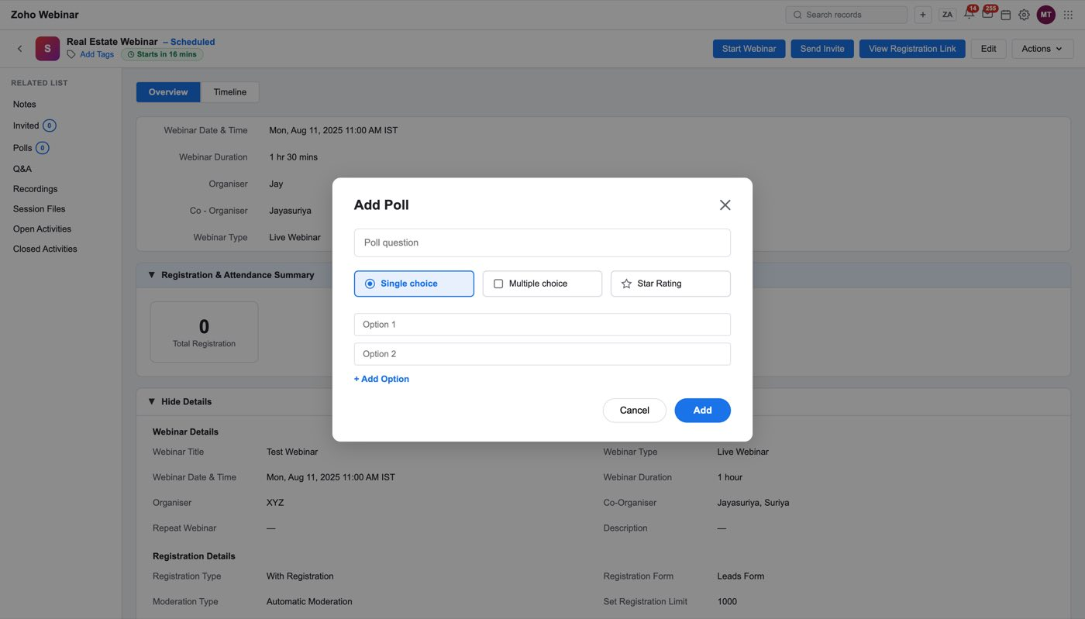
Figure 46 — Create Poll. The poll is authored before the session and answered during it
Q&A exists as a related list but is empty with a line saying so: "Q&A will be available after the webinar is completed." Recordings and Session Files are likewise empty.

8. A webinar that has happened
Same record, same rail. What changes is that every empty panel now has content, and three panels appear that did not exist before. Before the webinar the record collects; after the webinar it reports.
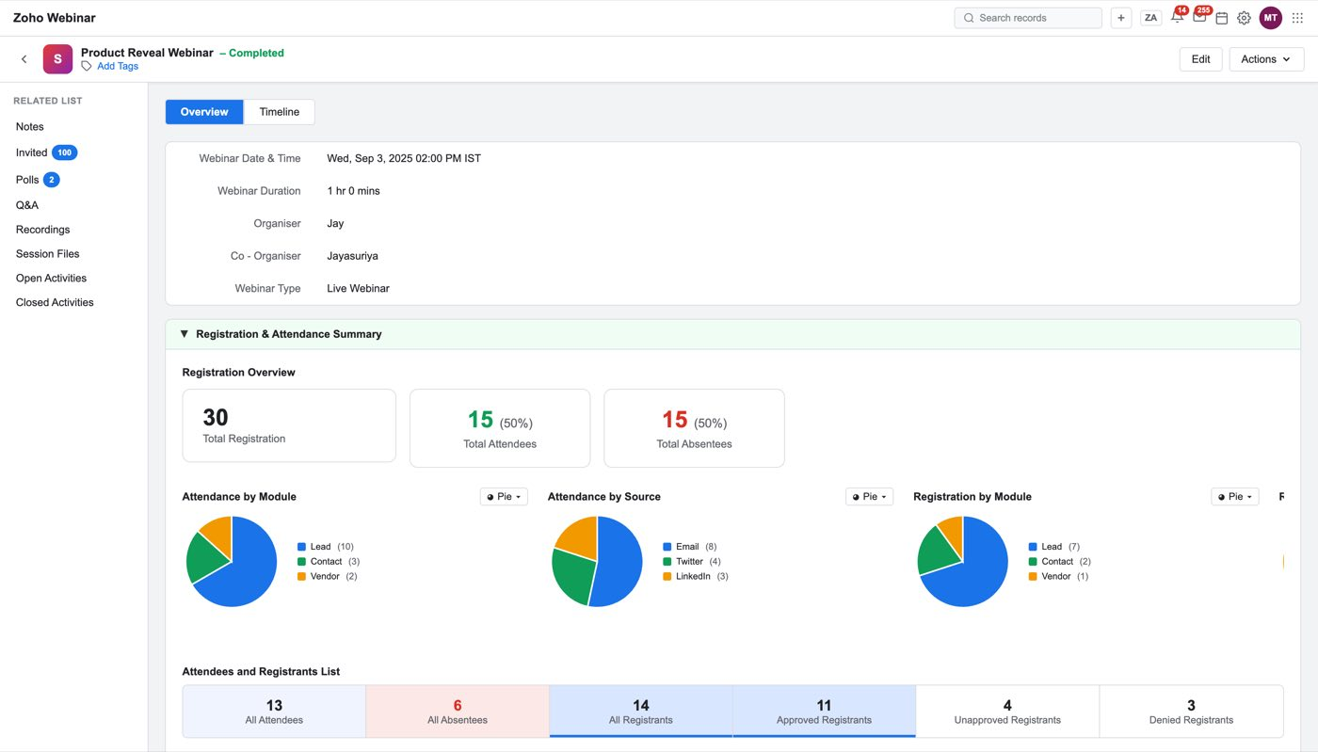
Figure 47 — A completed webinar. The pill by the title reads "— Completed"
 | Scheduled | Completed
Header actions | Start Webinar, Send Invite, View Registration Link | Edit, Actions (no Start, no Send Invite)
Registration & Attendance Summary | Registrations only | Registrations, attendees, absentees, and the module/source breakdowns
Attendees and Registrants List | — | Six tabs: All Attendees, All Absentees, All Registrants, Approved, Unapproved, Denied
Polls | Questions only | Questions with how the room answered
Q&A | "available after the webinar is completed" | Every question, who asked it, and the answer
Recordings / Session Files | Empty | The recording and whatever was shared
Webinar Revenue | Absent | ROI, pipeline, Deals Won, Deals in Pipeline

Registration and attendance
The summary band leads with three numbers — Total Registration, Total Attendees, Total Absentees, each with its percentage — then the breakdowns: attendance by module, attendance by source, registration by module, registration by source, and a daily registration trend with the peak day.
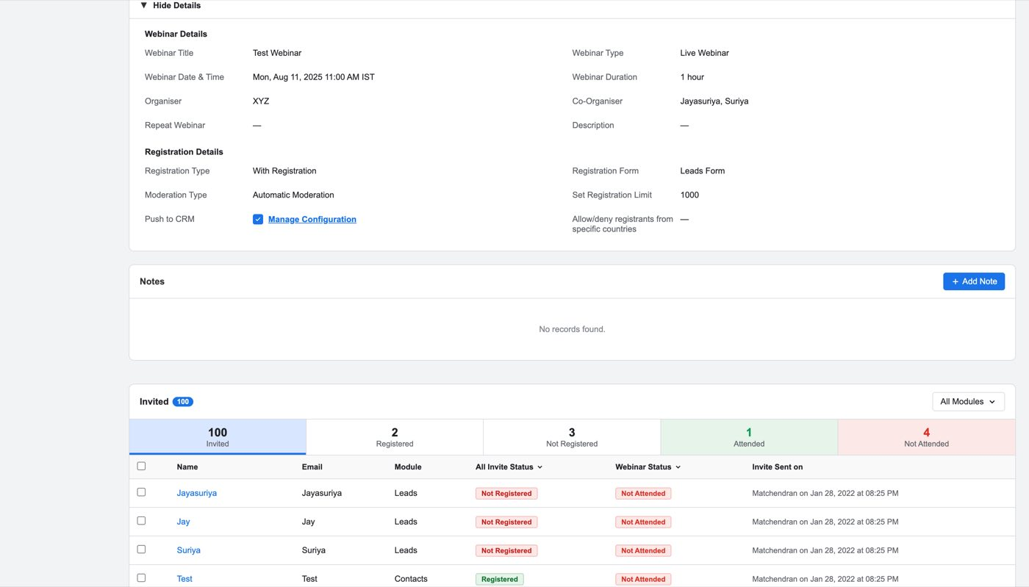
Figure 48 — The three headline numbers, then the pies. Every chart has a Pie / Bar switch
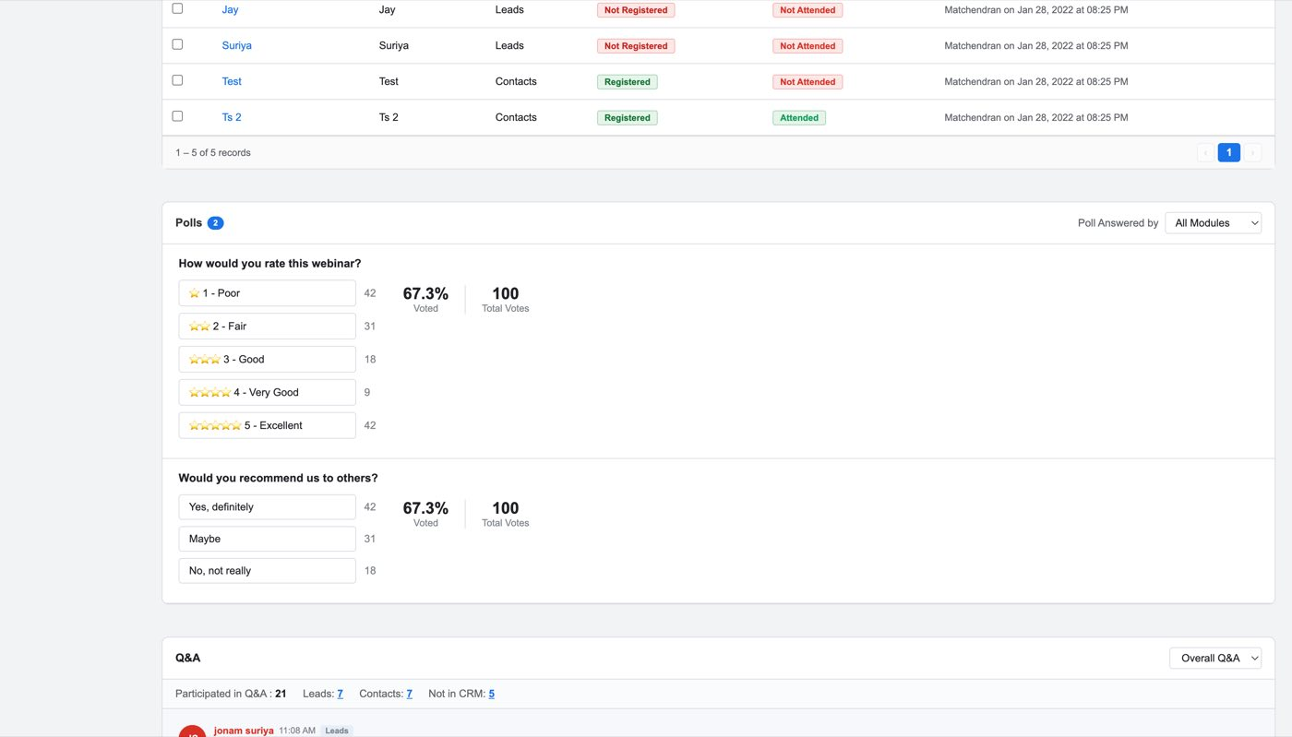
Figure 49 — Registration by Source. This is the panel the Email source-tracking link feeds

The people
Attendees and Registrants List is the panel a rep actually works from. Six tabs across the top with counts; the table gives name, email, the CRM module the person came from, their source, their poll count, whether they asked a question, when they registered and their Webinar Status — Attended or Not Attended.
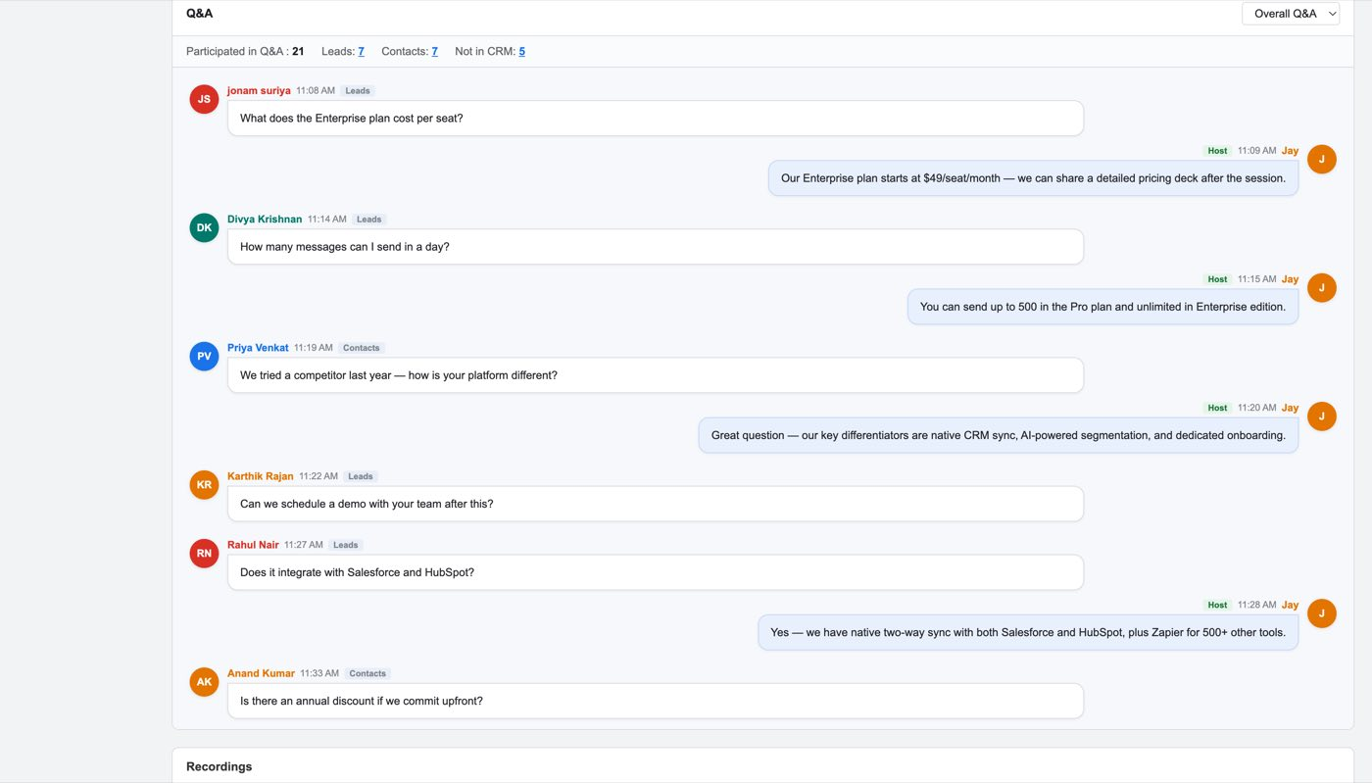
Figure 50 — One row per person. Module and Source are the two columns that make this a CRM screen rather than a webinar export
Sample use case
This is the "who do I call first" answer from the introduction. Jay sorts to Attended, filters to the module that matters, and the people who asked questions are marked in the Q&A column — a lead who sat through the hour and asked about minimum portfolio size is at the top of Monday's list, with their CRM history one click away.

Note
Mock defect. The sample registrant rows carry sources LinkedIn / Twitter / Direct on a webinar whose only real source is Email, and the tab counts (13 attendees, 6 absentees, 14 registrants) do not reconcile with the 30 / 15 / 15 in the summary above, nor with the 11 rows the table paginates. Sample data, not behaviour to reproduce.

Polls and Q&A
Polls now show the results per option. Q&A lists each question with who asked it, which module they came from, and the host's answer.
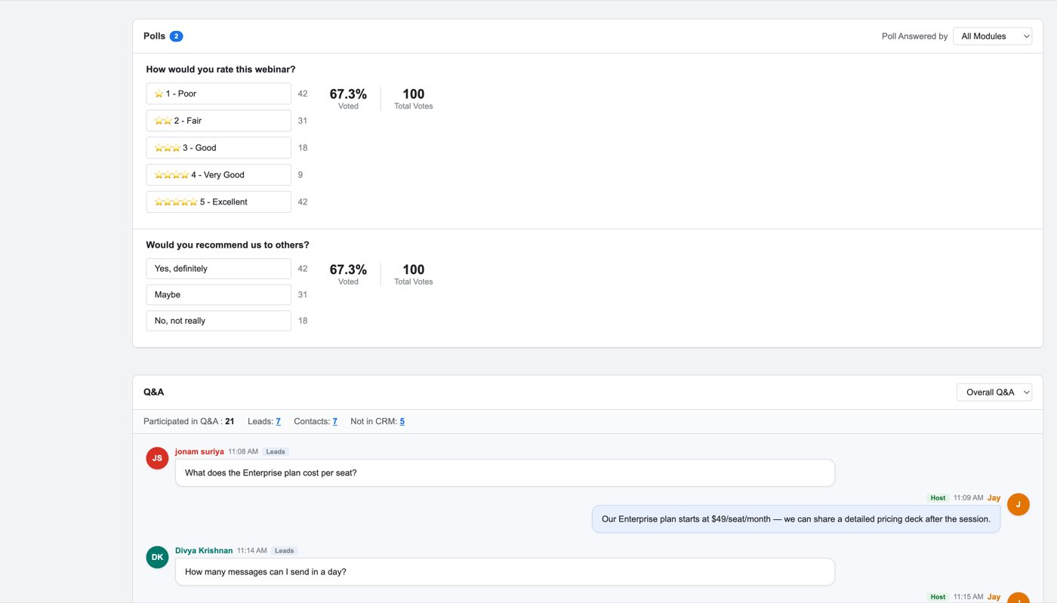
Figure 51 — Polls with the room's answers
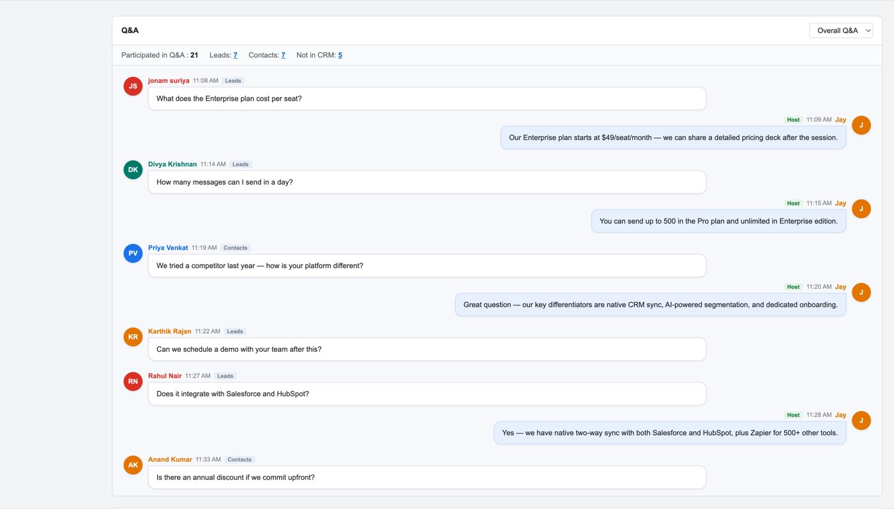
Figure 52 — Q&A. Every question is attached to the person who asked it, which is what makes it followable
Note
Mock content, not spec. The Q&A transcript is written as software-pricing questions ("What does the Enterprise plan cost per seat?"), which contradicts the wealth-management example used elsewhere. The structure is the point: question, asker, module, answer.

Webinar Revenue
The panel that justifies the integration to a sales leader. It is collapsed by default — click the band to open it.
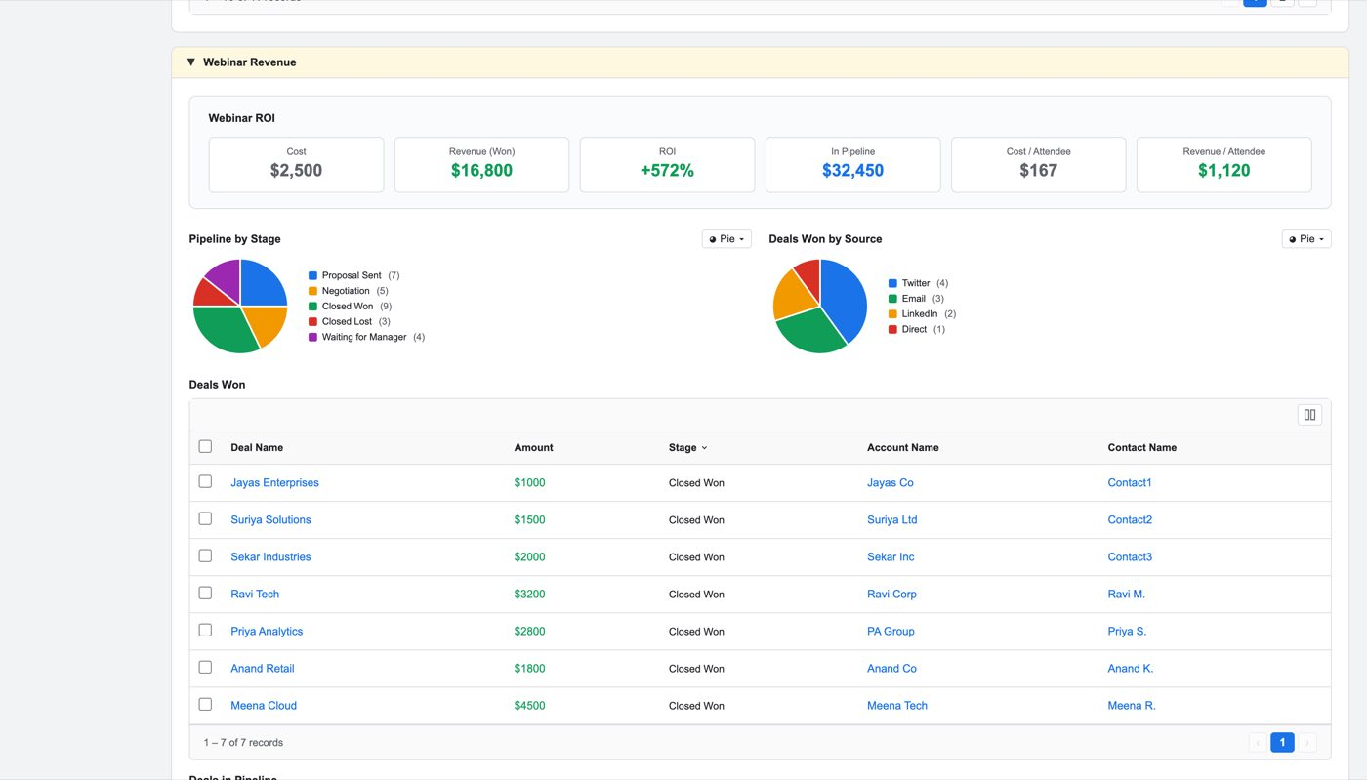
Figure 53 — Webinar ROI, the pipeline split, Deals Won by source, and the Deals Won table
Webinar ROI is six figures: Cost (the Webinar Cost from the create form), Revenue (Won), ROI %, In Pipeline, Cost / Attendee, Revenue / Attendee. Below it, Pipeline by Stage and Deals Won by Source, then Deals Won — deal name, amount, stage, account, contact — and a Deals in Pipeline table under it.
Note
Cost is the only input a user provides; every other figure derives from it and from the attributed deals. A webinar saved with no Webinar Cost reports no ROI and no cost per attendee.

Open question
Which deals qualify as influenced, and over what window, is not modelled. The attribution model splits revenue across webinars, but what makes a deal eligible in the first place — the contact attended, or registered, or was merely invited — is undecided and it changes every number in this panel.

9. On-demand webinars
An on-demand webinar has no start time: a recording sits behind a registration form and people watch when they like. The form reflects that.
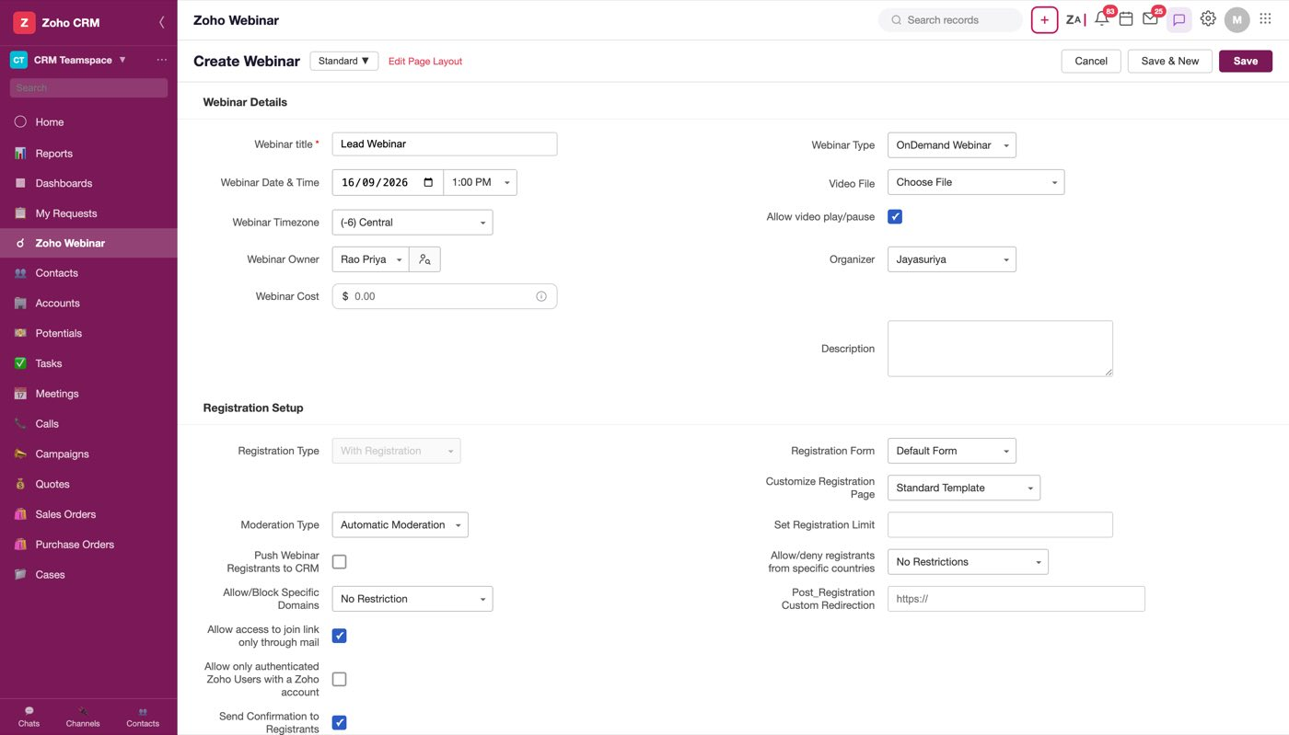
Figure 54 — On-demand. Video File replaces Webinar Duration, and Allow video play/pause sits between the file and the Organizer
What changes when Webinar Type is OnDemand Webinar:
- Video File replaces Webinar Duration — From Zoho Webinar Recordings, Upload Files / Documents, Zoho WorkDrive, Other Cloud Services.
- Allow video play/pause appears, on by default, positioned directly under Video File and above Organizer — the setting sits with the file it governs.
- Repeat Webinar and Co-Organizer are gone.
- Reminders and Follow-Ups are gone. There is no start time to remind anyone about.
- Registration Setup is otherwise identical, including Registration Form and Customize Registration Page.
Without Registration is the other branch of the same field, and it is worth seeing once: the whole registration block disappears and is replaced by join rules — Who can Join (Anyone can Join / Only Authenticated Users can Join), the country restriction, and one Send thank you email to attendees with its own template slot. There are no registrants on such a webinar, so there is nothing to confirm, remind or follow up in two directions.
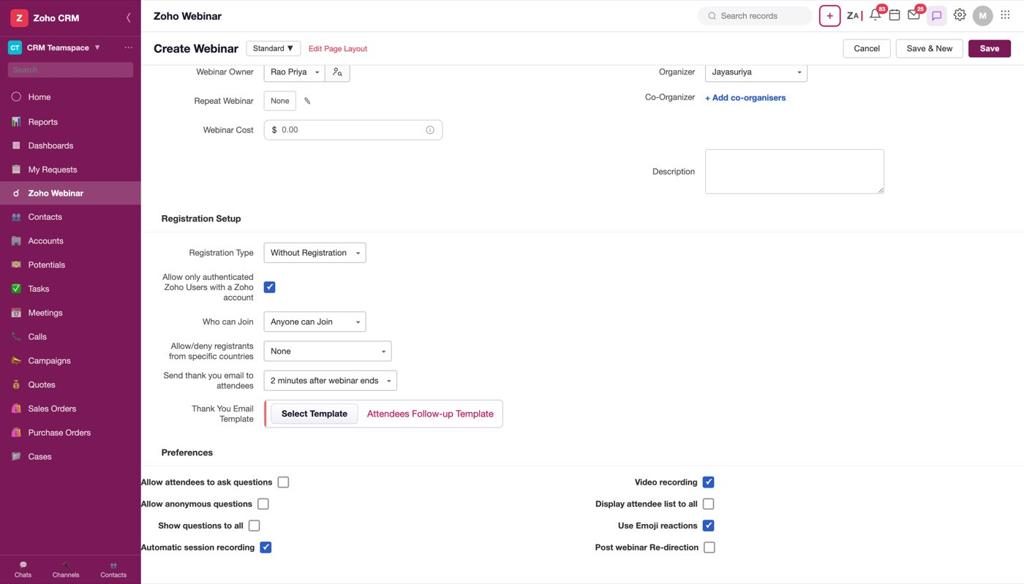
Figure 55 — Without Registration. No form, no moderation, no reminders — one thank-you email
The completed on-demand record reports the same way as a completed live one, including revenue.
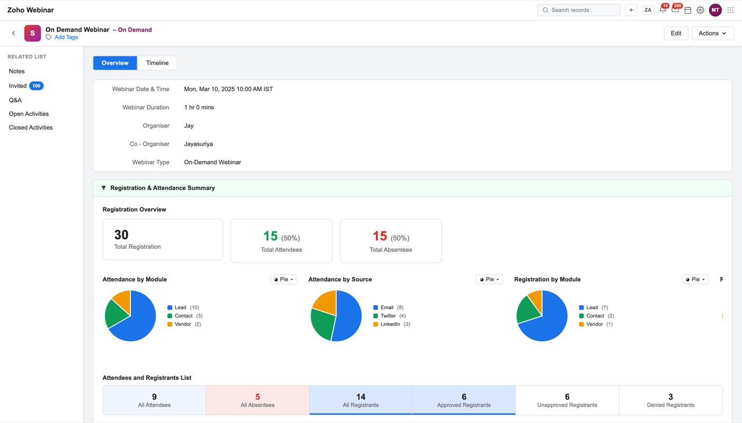
Figure 56 — A completed on-demand webinar. Same reporting, no session-time concepts
Open question
Send Invite on an on-demand webinar is not settled. The header still offers it, and inviting people to watch a recording is reasonable — but the invitation template's calendar links and "starts in" content do not apply. Decide whether the invitation is a different email for this type.

10. The emails

Where templates live
The webinar's default set lives in Modules and Fields ▸ Zoho Webinar ▸ Preferences, and Setup ▸ Templates lists them under the Zoho Webinar module.
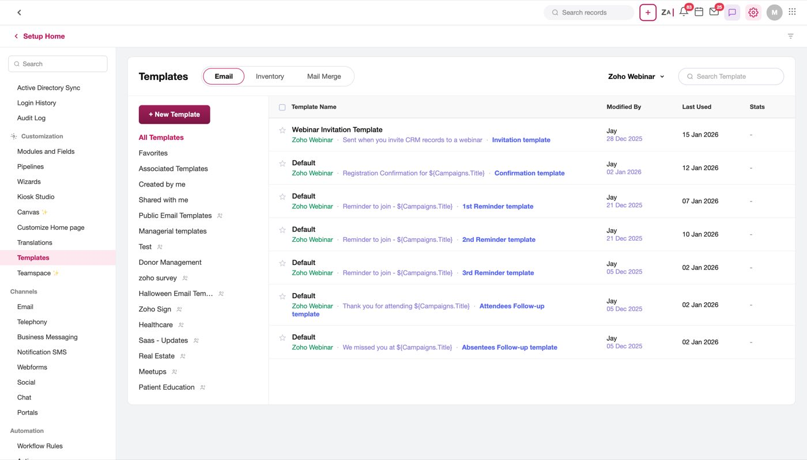
Figure 57 — Setup ▸ Templates filtered to Zoho Webinar. Six rows named "Default" plus the invitation
The shipped set is eight lifecycle emails, and only one of them is editable in CRM:
Row name | Subject | Type
Webinar Invitation Template | Sent when you invite CRM records to a webinar | Invitation
Default | Registration Confirmation for ${Campaigns.Title} | Confirmation
Default | Reminder to join - ${Campaigns.Title} | 1st Reminder
Default | Reminder to join - ${Campaigns.Title} | 2nd Reminder
Default | Reminder to join - ${Campaigns.Title} | 3rd Reminder
Default | Thank you for attending ${Campaigns.Title} | Attendees Follow-up
Default | We missed you at ${Campaigns.Title} | Absentees Follow-up

The six Default rows are Zoho Webinar's own templates, listed here for visibility rather than owned by CRM: they are read-only in the list, with no pencil. Clicking one previews it, and Edit in that preview opens Zoho Webinar's own editor in a new browser tab, with its own meeting.zoho.com address bar, because the template belongs to the other product. Saving there hands the template back (window.opener.zwSlotTemplateSaved) and closes the tab.
Figure 58 — A Default row previewed. Edit leaves CRM
Note
The Webinar Cancelled template is deliberately not in this list, and the invitation is the only row CRM edits in place. If you are adding a row here, the question to answer first is which product owns it.

Creating one
+ New Template opens Create Email Template: Select Module, and — only when the module is Zoho Webinar — an Email Type. Next opens the gallery on that type.
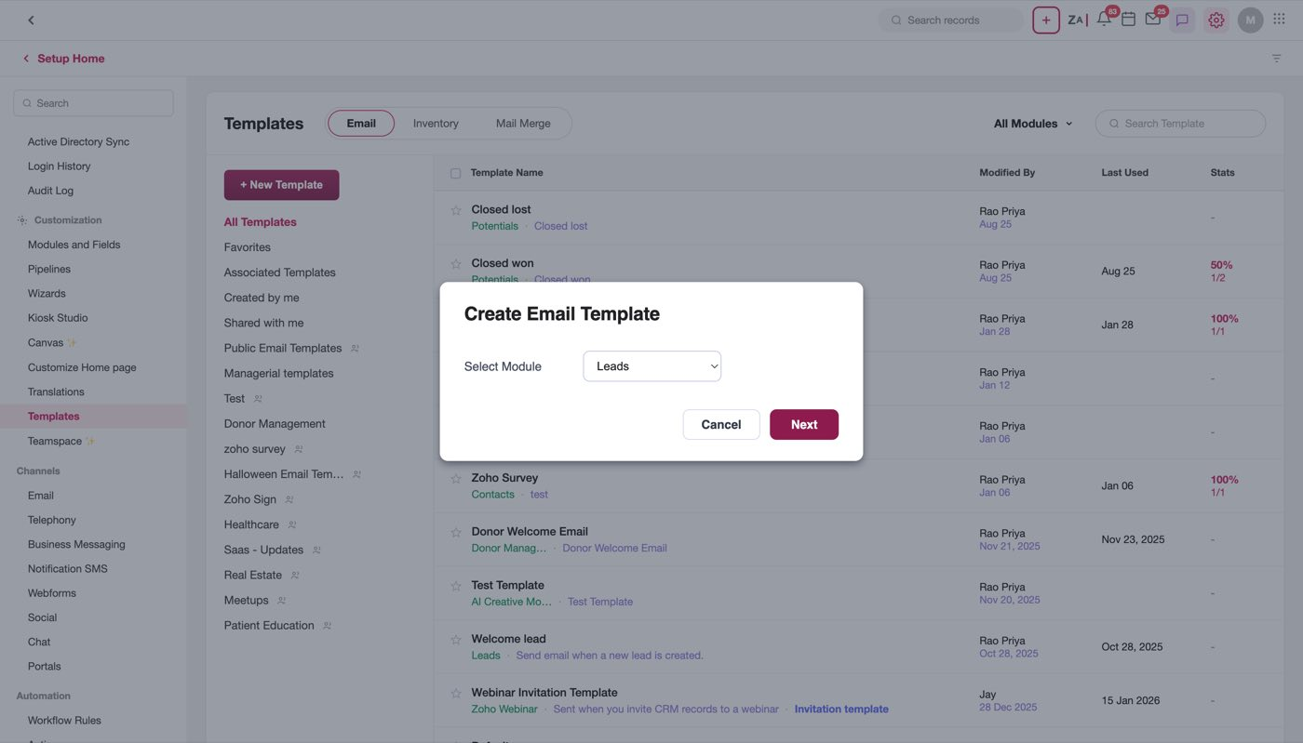
Figure 59 — Create Email Template. Email Type only appears for Zoho Webinar, because no other module's templates carry a lifecycle type
The gallery is the Email Notifications screen: a rail of the eight lifecycle emails on the left, and for the selected one its Quick Templates Default, any Custom Templates saved for it, and the six Basic layouts.
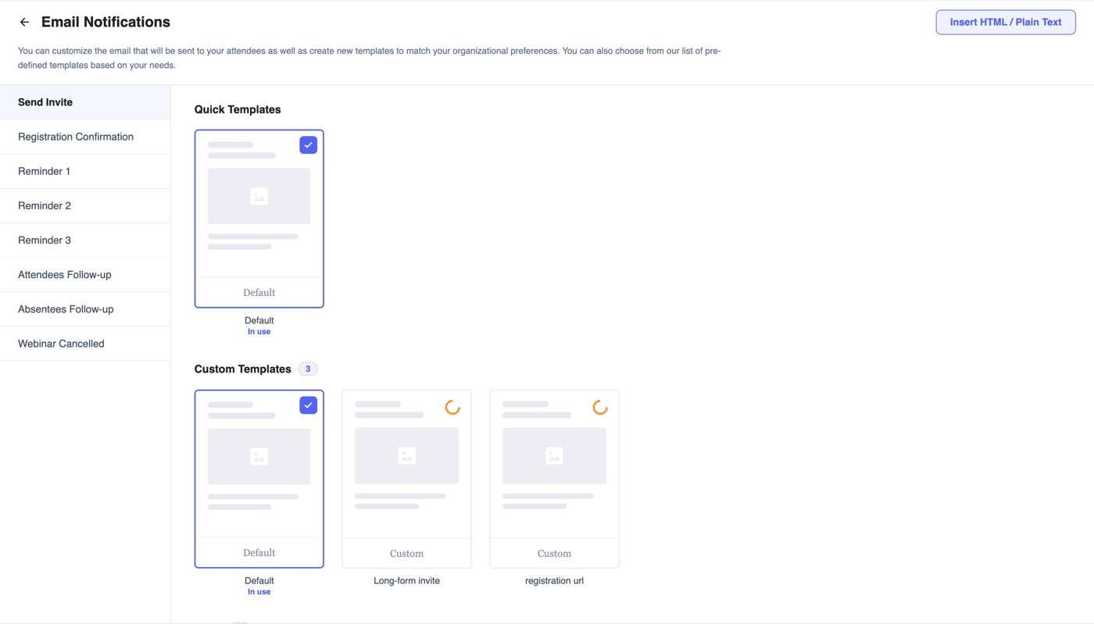
Figure 60 — The gallery on Send Invite. The rail picks the use case, and the use case stamps the type
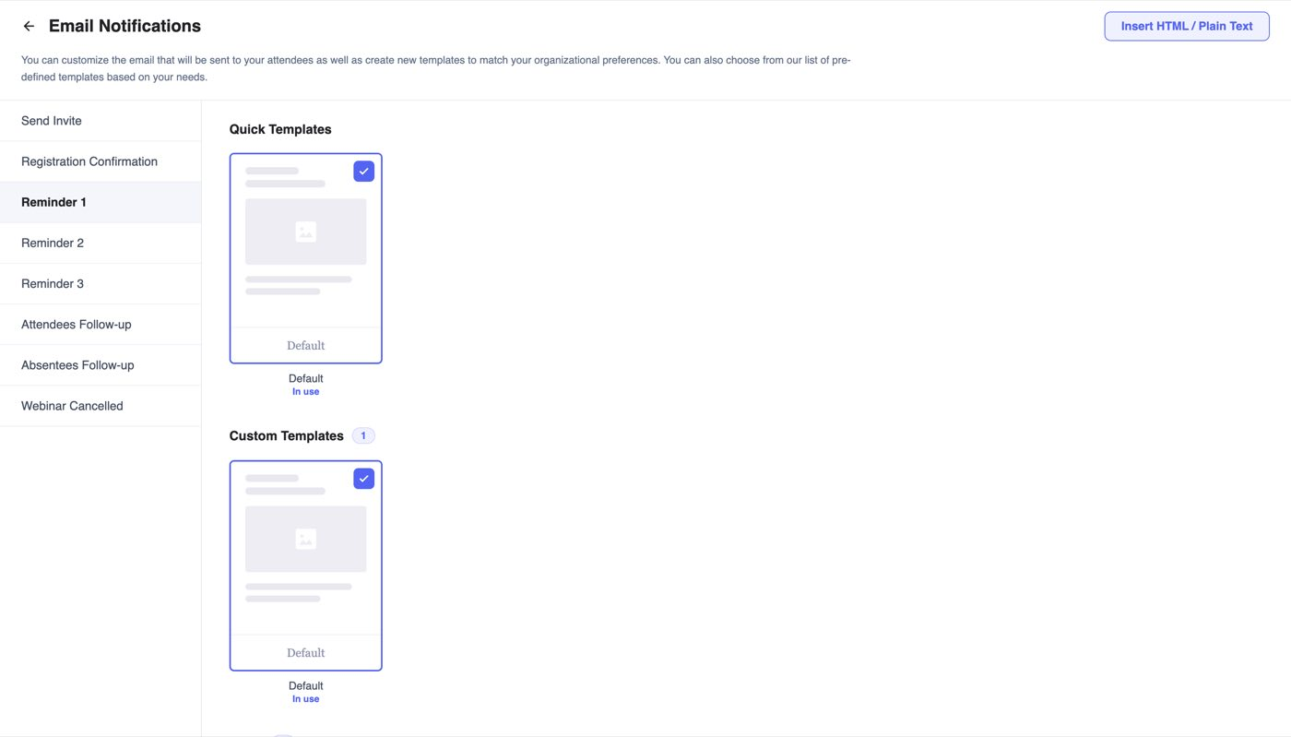
Figure 61 — The same screen on Reminder 1. The standing paragraph under the title explains what the screen is for
Selecting a card makes that template the live one for the email, and replaces the row in the Templates list rather than adding a second — one row per lifecycle email, always. Picking a Basic layout opens the editor.
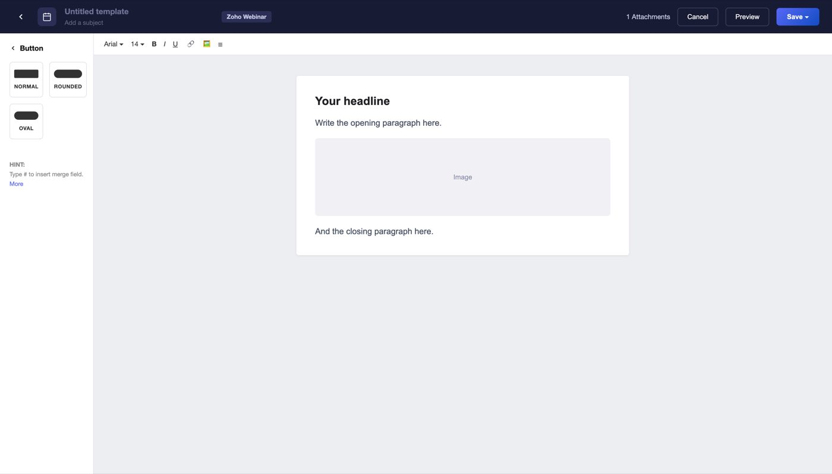
Figure 62 — The editor. Name and subject are real inputs, blank with placeholders, because nothing should be named for you
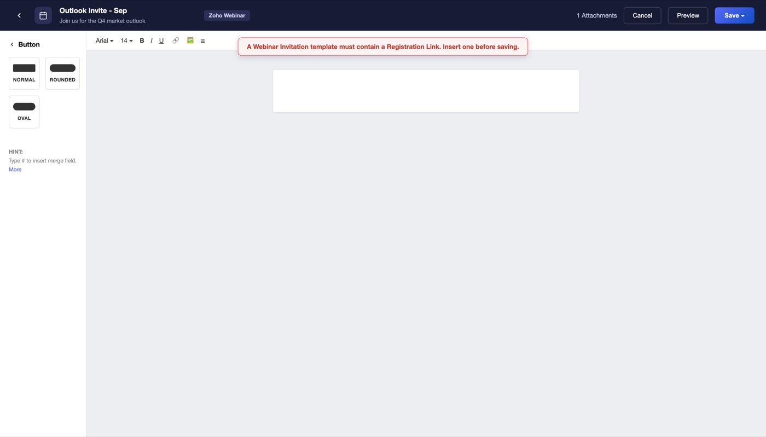
Figure 63 — Save asks for the name and the folder. Both are required; saving without either is refused inline

The type rules — the part to get right
A template's type decides what it may link to and what it must carry. These come straight out of TPL_TYPE_LINKS and TPL_REQUIRED_LINK; saving a template without its required link is refused.
Type | May link to | Must contain
Webinar Invitation | Web URL, Email, Registration Link, all four Add To Calendar links | Registration Link
Confirmation Email | Web URL, Join URL, Cancel Registration, calendars | Join URL
1st / 2nd / 3rd Reminder | Web URL, Join URL, Cancel Registration, calendars | Join URL
Attendees Follow-up | Web URL, Join URL, Recording Link, calendars | Recording Link
Absentees Follow-up | Web URL, Join URL, Recording Link, calendars | Recording Link
None | all of the above | nothing

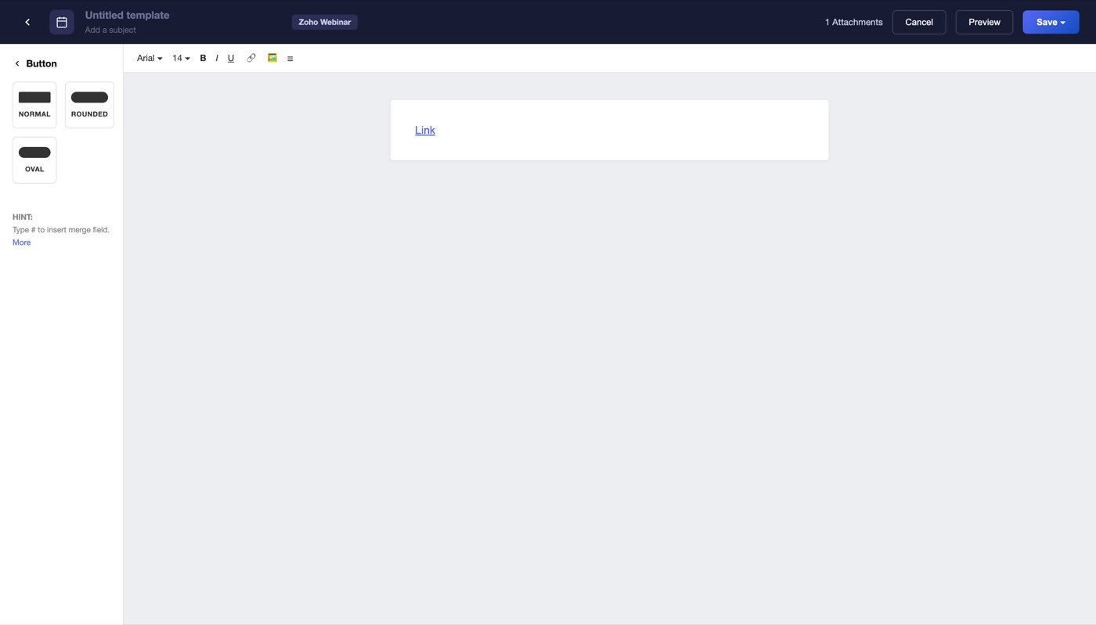
Figure 64 — Insert Link offers only the link types the template's own type allows
The reasoning is worth stating because it generalises: an invitation goes to a CRM record — someone who has not registered yet, so there is no registration to draw from, and the only useful link is the one that lets them register. Every later email goes to a registrant, so a per-person Join URL exists and a Registration Link would be meaningless.

Merge fields
Typing # in the editor opens the merge-field picker. The sources it offers follow the same rule:
- Webinar Invitation: Webinar Details, Users, Organization.
- Every later email: Registrations as well, listed first — the registrant's own name, email, timezone, Join URL, Cancel Registration, Add To Calendar links, Handouts and the rest.
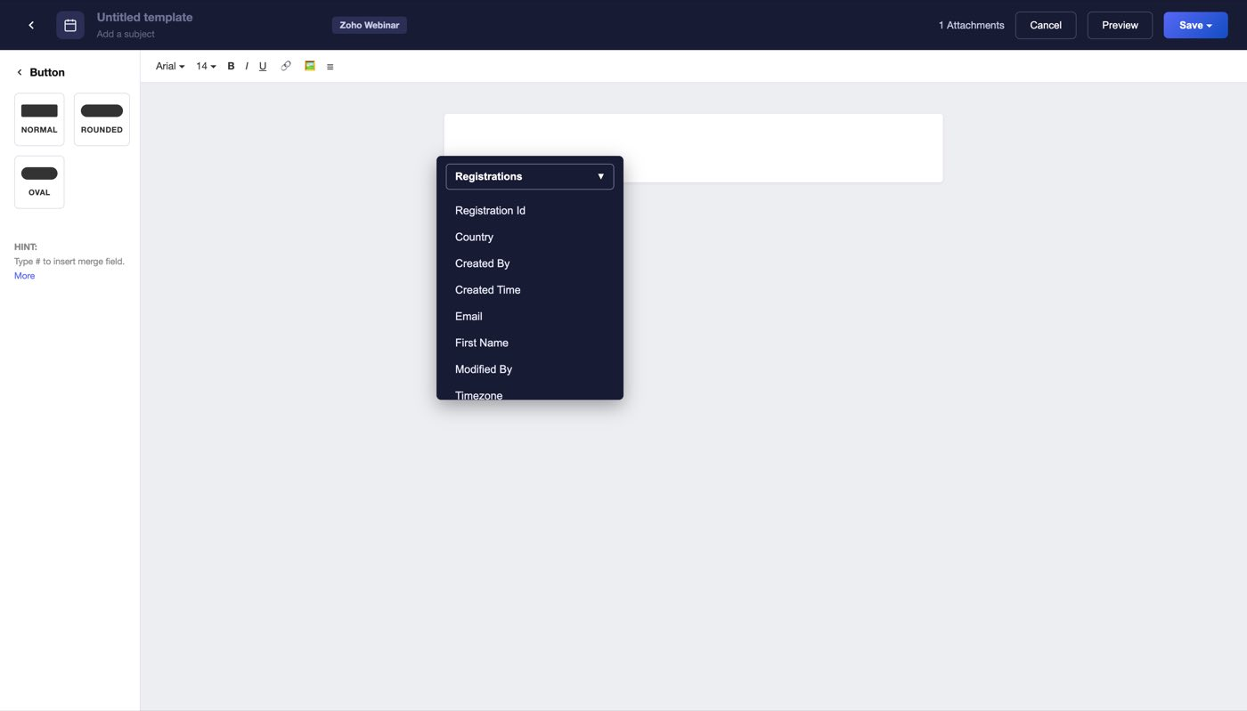
Figure 65 — A confirmation template's picker. Registrations is present and selected by default
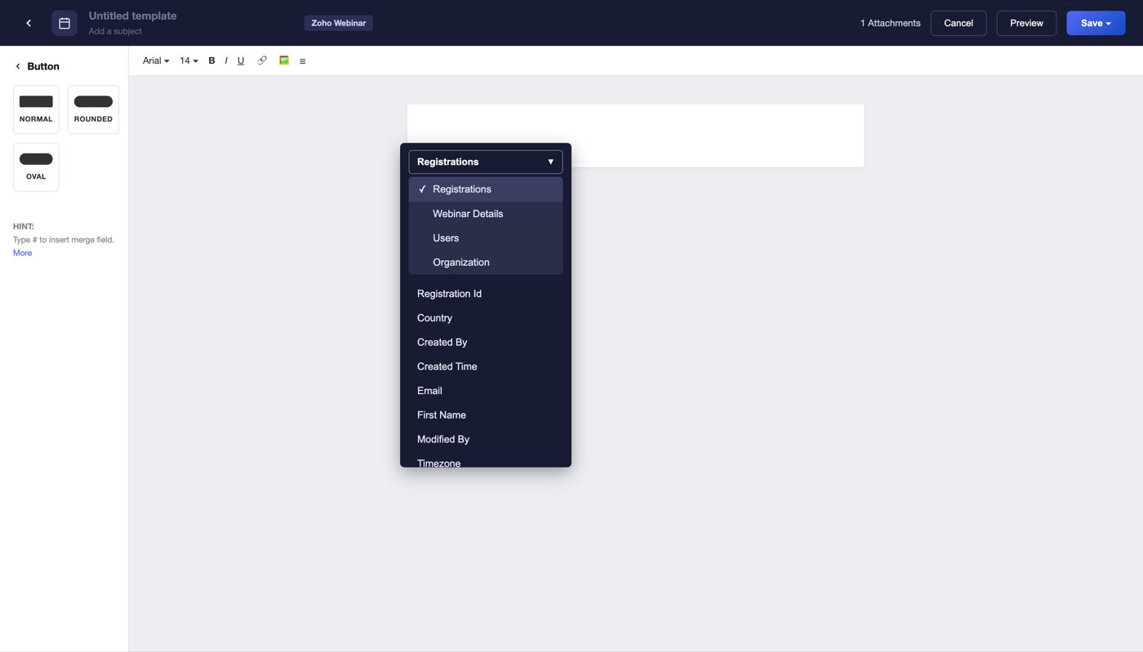
Figure 66 — The source switcher. Registrations, Webinar Details, Users, Organization
Note
Known gap, pre-existing. tplMergeModules() leads with Registrations for anything that is not a Webinar Invitation, including a plain Contacts template created from this screen — so a non-webinar template offers registrant fields rather than its own module's. It is out of scope for the webinar flows but it will look like a bug the first time somebody creates a Contacts template here.

11. Attribution
One person can attend three webinars before a deal closes. Without a rule, all three webinars report the whole deal and the year's webinar revenue reads three times what was actually sold. The attribution model is that rule, chosen once in setup and applied everywhere revenue appears.
Sample use case
A business owner attends Northline's March outlook webinar and does nothing, attends again in June and books a discovery call, then attends in September and signs — $12,000 of first-year fees. Three webinars, one deal. March found them, September closed them, June is the one that made them pick up the phone, and there is no true answer. Pick a rule or the totals are fiction.

The six models, with the copy the UI carries for each:
Model | What it does | The A → B → C example on the card
First Webinar Interaction | 100% of the deal revenue to the earliest webinar attended | Attends A → B → C, deal closes: A gets 100%
Last Webinar Interaction | 100% to the most recent webinar attended | Attends A → B → C, deal closes: C gets 100%
Linear (default) | Splits revenue equally across every webinar attended | Attends A → B → C → D: 25% each
Increasing Time Decay | Later webinars get more credit than earlier ones | Best when the last few touchpoints matter most
Decreasing Time Decay | Earlier webinars get more credit than later ones | Best when early awareness matters most
Position-Based | First and last get 40% each, the middle shares 20% | Best for U-shaped journeys

Two facts to build against: attribution is optional — the step says so, and it can be enabled later from the enabled panel — and changing the model recalculates every revenue figure in the product against the new rule, rather than applying only to deals closed from then on.
Open question
Whether a model change is retroactive is stated as an assumption here, not observed. The mock does not recalculate anything. Confirm before building, because the alternative — freezing attribution per deal at close time — is a different data model.

12. Things we still need to decide

Blocking
Two template types require a link the product does not produce. Attendees Follow-up and Absentees Follow-up must both carry a Recording Link, and saving without it is refused — but nothing in the flow guarantees a recording exists. Automatic session recording is a preference that can be switched off, and Include Recording for Attendees / Absentees are both off by default on the create form. So a webinar can legitimately be configured to send a follow-up that must contain a link to a recording that was never made. Decide which gives: the requirement, the default, or the link resolving to something graceful when there is no recording.

Product
- What a co-organiser can do — edit, start, see registrants, appear on the registration page — and whether an invited co-organiser is emailed at all.
- Custom registration pages: whether the picklist lists saved page templates by name, where one is authored, and what happens when a custom page and a custom form disagree about the fields.
- Send Invite on on-demand webinars: keep it, and with which email?
- Which deals count as influenced by a webinar, and over what window. This decides every figure in Webinar Revenue.
- Disconnecting the integration: what happens to synced webinars, pushed registrants and attribution history.
- Webinar Cancelled: the template type exists, but nothing in the flows cancels a webinar or sends it.

Engineering
- Save validation beyond the title: past dates, zero registration limits, non-numeric cost, on-demand with no video file.
- Whether an attribution model change recalculates history (see above).
- Source rows are created once — confirm the intended behaviour when invites are sent from two different modules, or on two different days.
- Merge sources for non-webinar templates created from the gallery (tplMergeModules() leads with Registrations regardless of module).
- Daily mass-email limit: the footer shows 0 / 1000. Where that limit comes from, and what happens at it, is not modelled.

Design
- The Select Template dialog is inconsistent: from a create-form slot the folder control is a static Zoho Webinar label, and from Send Invite it is an All Templates dropdown. Pick one.
- Webinar Category vs Webinar Type as two list columns reads as redundant on on-demand rows.
- The eye on Customize Registration Page appears only on hover, which is invisible to a keyboard or touch user.

Assumptions this document makes
- A webinar record is a CRM record in a real module, with layouts, sharing and field-level permissions behaving as CRM's do. The mock shows the chrome but does not model permissions.
- Registrant → CRM record creation is the Push Webinar Registrants to CRM setting, and nothing else creates records.
- The six Default rows in Setup ▸ Templates are Zoho Webinar's templates surfaced read-only, not copies owned by CRM.
- Counts on the completed record (attendees, absentees, registrants) come from Zoho Webinar and are not recomputed in CRM.

Mock defects — do not reproduce
- The Details panel on every webinar record shows the same hardcoded values (Test Webinar, XYZ, Leads Form, 1000).
- The registrant list's sources include LinkedIn / Twitter / Direct on a webinar whose only source is Email, and the tab counts do not reconcile with the summary or the rows.
- Webinar Duration lists 1 hr twice (the option list starts 1 hr, 1 hr, 2 hr…).
- The Q&A transcript is SaaS-pricing content on a wealth-management example.
- Several stub alert() calls remain from earlier work (Visit Webinar module, Notify Suriya, Add Meeting, Search CRM users). They freeze the renderer until dismissed; do not wire real actions to them.

13. Appendix A — every field in the create form
Pulled from the DOM, in the order the form shows them, with the picklist values verbatim. Duplicate option values have been collapsed except where noted in the mock-defect list.

Live webinar, With Registration (the default form)
This is the full form. Webinar title is the only required field.
Field | Type | Required | Default | Options / notes
Webinar title | Text | yes | — | placeholder Enter webinar title
Webinar Type | Picklist | no | Live Webinar | Live Webinar, OnDemand Webinar
Webinar Date & Time | Picklist | no | 10:00 AM | 9:00 AM, 10:00 AM, 11:00 AM, 12:00 PM, 1:00 PM, 2:00 PM
Webinar Duration | Picklist | no | 1 hr | 1 hr, 2 hr, 3 hr, 4 hr, 5 hr, 6 hr, 7 hr, 8 hr, 9 hr, 10 hr, 11 hr, 12 hr, 13 hr, 14 hr, 15 hr, 16 hr, 17 hr, 18 hr, 19 hr, 20 hr, 21 hr, 22 hr, 23 hr, 24 hr, 00 min, 15 min, 30 min, 45 min
Webinar Timezone | Picklist | no | (-6) Central | (-5) Eastern, (-6) Central, (-7) Mountain, (-8) Pacific, (+0) UTC, (+5:30) IST
Webinar Owner | Picklist | no | Rao Priya | Rao Priya, Jay Acme, Mark Acme, Suriya
Organizer | Picklist | no | Jayasuriya | Jayasuriya, Morrison Troy
Repeat Webinar | Compound control | no | Repeat Webinar None ✎ | see the section above
Co-Organizer | Compound control | no | Co-Organizer + Add co-organisers | see the section above
Webinar Cost | Text | no | — | placeholder 0.00
Description | Textarea | no | —
Registration Type | Picklist | no | With Registration | With Registration, Without Registration
Registration Form | Picklist | no | Default Form | Default FormPreview, Real Estate FormPreview, Stock Trading FormPreview, + Create New Form
Customize Registration Page | Picklist | no | Standard Template | Standard Template, Custom Created
Moderation Type | Picklist | no | Automatic Moderation | Automatic Moderation, Manual Moderation
Set Registration Limit | Text | no | —
Push Webinar Registrants to CRM | Checkbox | no | off
Allow/deny registrants from specific countries | Picklist | no | No Restrictions | No Restrictions, Allow registrants from Countries, Block registrants from Countries
Allow/Block Specific Domains | Picklist | no | No Restriction | No Restriction, Allow specific email domains, Block specific email domains
Post_Registration Custom Redirection | Text | no | — | placeholder https://
Allow access to join link only through mail | Checkbox | no | on
Allow only authenticated Zoho Users with a Zoho account | Checkbox | no | off
Send Confirmation to Registrants | Checkbox | no | on
Confirmation Email Template | Compound control | no | Confirmation Email Template Select TemplateWebinar Confirmat | see the section above
1st Reminder | Picklist | no | 15 mins before the webinar | 2 mins before the webinar, 5 mins before the webinar, 10 mins before the webinar, 15 mins before the webinar, 30 mins before the webinar, 1 hour before the webinar, 2 hours before the webinar, 6 hours before the webinar, 12 hours before the webinar, 1 day before the webinar, 1 week before the webinar
1st Reminder Template | Compound control | no | 1st Reminder Template Select Template1st Reminder Template | see the section above
2nd Reminder | Picklist | no | None | None, 2 mins before the webinar, 5 mins before the webinar, 10 mins before the webinar, 15 mins before the webinar, 30 mins before the webinar, 1 hour before the webinar, 2 hours before the webinar, 6 hours before the webinar, 12 hours before the webinar, 1 day before the webinar, 1 week before the webinar
3rd Reminder | Picklist | no | None | None, 2 mins before the webinar, 5 mins before the webinar, 10 mins before the webinar, 15 mins before the webinar, 30 mins before the webinar, 1 hour before the webinar, 2 hours before the webinar, 6 hours before the webinar, 12 hours before the webinar, 1 day before the webinar, 1 week before the webinar
Send Follow-up Email to Attendees | Picklist | no | 2 mins after the webinar ends | None, 2 mins after the webinar ends, 5 mins after the webinar ends, 10 mins after the webinar ends, 15 mins after the webinar ends, 1 hour after the webinar ends, 2 hours after the webinar ends, 6 hours after the webinar ends, 1 day after the webinar ends
Send Follow-up Email to Absentees | Picklist | no | 2 mins after the webinar ends | None, 2 mins after the webinar ends, 5 mins after the webinar ends, 10 mins after the webinar ends, 15 mins after the webinar ends, 1 hour after the webinar ends, 2 hours after the webinar ends, 6 hours after the webinar ends, 1 day after the webinar ends
Attendees Follow-up Template | Compound control | no | Attendees Follow-up Template Select TemplateAttendees Follow | see the section above
Absentees Follow-up Template | Compound control | no | Absentees Follow-up Template Select TemplateAbsentees Follow | see the section above
Include Recording for Attendees | Checkbox | no | off
Include Recording for Absentees | Checkbox | no | off

On-demand webinar
Differences from the list above are described in On-demand webinars. Note the Webinar Type default below reads Live Webinar because the state was set programmatically for the capture; through the UI the button reads OnDemand Webinar.
Field | Type | Required | Default | Options / notes
Webinar title | Text | yes | Lead Webinar | placeholder Enter webinar title
Webinar Type | Picklist | no | Live Webinar | Live Webinar, OnDemand Webinar
Webinar Date & Time | Picklist | no | 10:00 AM | 9:00 AM, 10:00 AM, 11:00 AM, 12:00 PM, 1:00 PM, 2:00 PM
Video File | Picklist | no | Choose File | From Zoho Webinar Recordings, Upload Files / Documents, Zoho WorkDrive, Other Cloud Services
Webinar Timezone | Picklist | no | (-6) Central | (-5) Eastern, (-6) Central, (-7) Mountain, (-8) Pacific, (+0) UTC, (+5:30) IST
Allow video play/pause | Checkbox | no | on
Webinar Owner | Picklist | no | Rao Priya | Rao Priya, Jay Acme, Mark Acme, Suriya
Organizer | Picklist | no | Jayasuriya | Jayasuriya, Morrison Troy
Webinar Cost | Text | no | — | placeholder 0.00
Description | Textarea | no | —
Registration Type | Picklist | no | With Registration | With Registration, Without Registration
Registration Form | Picklist | no | Default Form | Default FormPreview, Real Estate FormPreview, Stock Trading FormPreview, + Create New Form
Customize Registration Page | Picklist | no | Standard Template | Standard Template, Custom Created
Moderation Type | Picklist | no | Automatic Moderation | Automatic Moderation, Manual Moderation
Set Registration Limit | Text | no | —
Push Webinar Registrants to CRM | Checkbox | no | off
Allow/deny registrants from specific countries | Picklist | no | No Restrictions | No Restrictions, Allow registrants from Countries, Block registrants from Countries
Allow/Block Specific Domains | Picklist | no | No Restriction | No Restriction, Allow specific email domains, Block specific email domains
Post_Registration Custom Redirection | Text | no | — | placeholder https://
Allow access to join link only through mail | Checkbox | no | on
Allow only authenticated Zoho Users with a Zoho account | Checkbox | no | off
Send Confirmation to Registrants | Checkbox | no | on
Confirmation Email Template | Compound control | no | Confirmation Email Template Select TemplateWebinar Confirmat | see the section above

Without Registration
Registration Setup collapses to access rules and a single thank-you email.
Field | Type | Required | Default | Options / notes
Webinar title | Text | yes | — | placeholder Enter webinar title
Webinar Type | Picklist | no | Live Webinar | Live Webinar, OnDemand Webinar
Webinar Date & Time | Picklist | no | 10:00 AM | 9:00 AM, 10:00 AM, 11:00 AM, 12:00 PM, 1:00 PM, 2:00 PM
Webinar Duration | Picklist | no | 1 hr | 1 hr, 2 hr, 3 hr, 4 hr, 5 hr, 6 hr, 7 hr, 8 hr, 9 hr, 10 hr, 11 hr, 12 hr, 13 hr, 14 hr, 15 hr, 16 hr, 17 hr, 18 hr, 19 hr, 20 hr, 21 hr, 22 hr, 23 hr, 24 hr, 00 min, 15 min, 30 min, 45 min
Webinar Timezone | Picklist | no | (-6) Central | (-5) Eastern, (-6) Central, (-7) Mountain, (-8) Pacific, (+0) UTC, (+5:30) IST
Webinar Owner | Picklist | no | Rao Priya | Rao Priya, Jay Acme, Mark Acme, Suriya
Organizer | Picklist | no | Jayasuriya | Jayasuriya, Morrison Troy
Repeat Webinar | Compound control | no | Repeat Webinar None ✎ | see the section above
Co-Organizer | Compound control | no | Co-Organizer + Add co-organisers | see the section above
Webinar Cost | Text | no | — | placeholder 0.00
Description | Textarea | no | —
Registration Type | Picklist | no | With Registration | With Registration, Without Registration
Allow only authenticated Zoho Users with a Zoho account | Checkbox | no | on
Who can Join | Picklist | no | Anyone can Join | Anyone can Join, Only Authenticated Users can Join
Allow/deny registrants from specific countries | Picklist | no | None | None, Allow registrants from Countries, Block registrants from Countries
Send thank you email to attendees | Picklist | no | 2 minutes after webinar ends | 2 minutes after webinar ends, 5 mins after webinar ends, 10 mins after webinar ends
Thank You Email Template | Compound control | no | Thank You Email Template Select TemplateAttendees Follow-up | see the section above

14. Appendix B — integration settings, templates and directories

Integration setup (the four-step wizard)
Step | Field | Type | Default | Options / notes
1 | Email | Text | jonamsuriya@gmail.com (mock) | The Zoho account being connected
1 | Organisation | Picklist | Acme Corp Webinars | Acme Corp Webinars, ClientCo Marketing, Consulting Practice. Rule shown under the field: "Only one organisation can be connected to CRM at a time."
2 | Sync past webinars? | Radio | Yes | Yes / No. Backed by a hidden input setup-sync-past-select holding yes/no
3 | Who Can Participate From CRM | Checkbox list + search | Leads, Contacts (locked on) | Leads\, Contacts\, Vendors, Donors, Volunteers, Members, Students, Alumni, Partners, Speakers, Referrals, Patients, Subscribers
4 | Enable Deal Revenue Attribution | Toggle | on | Turning it off hides the model cards
4 | Revenue Attribution Type | Cards (single select) | Linear | First Webinar Interaction, Last Webinar Interaction, Linear, Increasing Time Decay, Decreasing Time Decay, Position-Based

Footer buttons per step: Cancel + Next on steps 1–3, Cancel + Enable Integration on step 4.
Note
INVITE_MODULES — the list Send Invite's dropdown draws from — is ["Leads","Contacts","Vendors","Custom Module 1"], and it is intersected with the participating list. So Custom Module 1 can never be switched on from step 3 (it is not in IM_MODULES), and the Send Invite dropdown offers Leads and Contacts until Vendors is ticked. Two lists that have to agree is the kind of thing that rots; consider one source.

Template types and keys
Use case key | Rail label | Default template name | Email Type in the list
sendInvite | Send Invite | Send Invite Template | Invitation
confirmation | Registration Confirmation | Webinar Confirmation Template | Confirmation
reminder1 | Reminder 1 | 1st Reminder Template | 1st Reminder
reminder2 | Reminder 2 | 2nd Reminder Template | 2nd Reminder
reminder3 | Reminder 3 | 3rd Reminder Template | 3rd Reminder
attendeesFollowup | Attendees Follow-up | Attendees Follow-up Template | Attendees Follow-up
absenteesFollowup | Absentees Follow-up | Absentees Follow-up Template | Absentees Follow-up
cancellation | Webinar Cancelled | Webinar Cancelled Template | Webinar Cancelled

Merge sources, verbatim
Webinar Details — Webinar Title, Webinar Date & Time, Webinar Organiser, Webinar Duration, Description.
Registrations — Registration Id, Country, Created By, Created Time, Email, First Name, Modified By, Timezone, Add To Google Calendar, Add To Yahoo Calendar, Add To Outlook Calendar, Add To Zoho Calendar, Add To Calendar, Join URL, Handouts, Cancel Registration, Audio Details, Registration URL, Full Name, Last Name, Abuse Email, iOS app URL.
Leads — Lead Id, Lead Owner, Company, First Name, Last Name, Title, Email, Phone, Mobile, Lead Source, Industry, City, State, Country.
Contacts — Contact Id, Contact Owner, Account Name, First Name, Last Name, Title, Email, Phone, Mobile, Department, Mailing City, Mailing State, Mailing Country.
Plus Users and Organization on every type.

Link types a template can insert
Web URL, Email, Registration Link, Join URL, Cancel Registration, Recording Link, Add To Calendar, Add To Google Calendar, Add To Yahoo Calendar, Add To Outlook Calendar, Add To Zoho Calendar — filtered per type by the table in The emails.

Co-organiser directories (mock data)
Source | People
CRM users | Rao Priya, Mann Michael, Jayasuriya, Morrison Troy
Webinar users | Rao Priya, Jayasuriya, Luxe Martin, Suriya, Mark Acme

Rao Priya and Jayasuriya appear in both on purpose — that is what makes the duplicate error reachable.

Registration page field sets
 | Standard Template | Custom Created
Fields | First Name\, Last Name\, Email Address\* | First Name\, Last Name\, Email Address\, Phone Number\, Company, Portfolio Size

Where each flow starts, for testing
Flow | Entry
Marketplace card | openSettingsModal(); integOpenZoho()
Integration intro / setup / enabled panel | integShowPanel('integ-intro-panel' / 'integ-setup-panel' / 'integ-enabled-panel'), then setupStep(n)
Create form | goToForm()
Webinar list | goToList()
A webinar record | openWebinarDetail(record, isCompleted, hasInvited)
Setup ▸ Templates | openSettingsModal(); openTemplatesPage(); tplPagePickModule('Zoho Webinar')
Template gallery | openUsecaseGallery('<use case key>')
Add Co-organisers panel | coOrgOpen(document.querySelector('#coOrgGroup .coorg-add'))
Registration page preview | `rpPreview(event, 'standard' \

The screenshots in this document were captured with docs/prd/master/shoot.mjs against http://localhost:8090/webinar.html; shots.json holds the click path for every figure, so any screen here can be reproduced exactly.

